KUK. SKILL DEV. (RUSA)

Admission Brochure 2019-20

SHORT-TERM CERTIFICATE COURSES IN SKILL DEVELOPMENT
(Under RUSA)
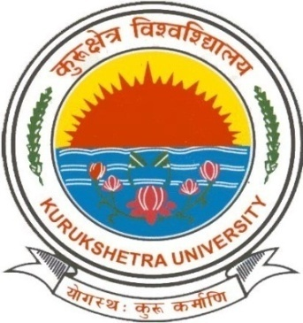

KURUKSHETRA UNIVERSITY KURUKSHETRA
(Established by the State Legislature Act XII of 1956)
(‘A⁺’ Grade NAAC Accredited)

Website: www.kuk.ac.in

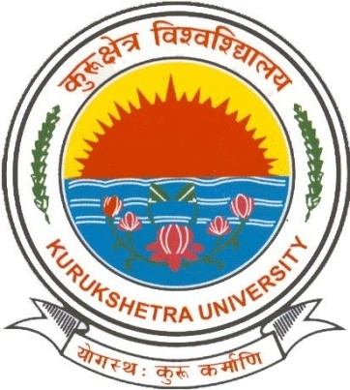

VISION
Be globally acknowledged as a distinguished Centre of academic excellence.

MISSION
To prepare a class of proficient scholars and professionals with ingrained human values and commitment to expand the frontiers of knowledge for the advancement of society.

KURUKSHETRAUNIVERSITY

Located in Kurukshetra, the land of the Gita, Kurukshetra University is a premier Institute of higher learning in India. It is spread over 400 acres of land on the south bank of the holy tank, Brahmsarovar. Its foundation stone was laid on 11 January 1957 by Bharatratna Dr. Rajendra Prasad, the first President of the IndianRepublic. Since then it has aimed at pursuing excellence in teaching and research in science, technology, humanities, social sciences, performing arts and sports.
Today, Kurukshetra University is offering a world-class education to students from throughout the country, by providing a learning experience designed to develop intellectual abilities, as well as social, moral and ethical values. In doing so the University is equipping its students with the skills, insights, attitudes and practical experience that will enable them to become discerning citizens.

The University’s programs combine the enduring value of a liberal arts education with the skills and experience offered by professional departments. The University has 472 qualified teaching faculty members. The University also has 390 affiliated colleges and institutes situated in the Districts of Ambala, Panipat, Kaithal, Yamuna Nagar, Hisar, Fatehabad, Jind, Karnal, Sirsa, Kurukshetra and Panchkula.

The Campus of the University has often been rated as one of the most beautiful campuses in India. It resembles a large, self-contained village with lecture theatres, seminar rooms, accommodation, cafeterias, canteens, shops and sports facilities, libraries and laboratories all within easy walking distance.The most remarkable feature of the campus is the seamless interconnection of nature and the built environment. There are a number of lush green gardens, water fountains and sidewalks which provide ideal environment on the campus for study and leisure.
The National Assessment and Accreditation Council (NAAC), an autonomous body of the University Grants Commission to assess and accredit universities and colleges, has conferred an ‘A⁺’ grade to Kurukshetra University. The University has made a mark on the international map as accreditation of educational institutions is now acknowledged as an important indicator of their quality and relevance all over the world.
In the emerging global scenario of competition-focused education and training, quality sustenance and quality enhancement in the institutions has gained paramount importance. The Internal Quality Assurance Cell works to ensures quality in different activities related to academics and administration of the university. The Cell set up in the University has been effectively functioning for the last many years. Various improvement strategies based on feedback from the stakeholders likes students, parents are recommended by the IQAC towards developing quality culture in the campus.

The Directorate of Distance Education of Kurukshetra university, Kurukshetra meets the needs of thousands who wish to enrol for different courses. Today the Directorate is engaged in providing Under-Graduate and Post-Graduate education in about 45 courses having an enrolment of 37,500 students. In addition to conventional courses, the Directorate also offers professional courses in the areas of Computer, IT, Commerce, Management, Finance, Marketing, Law, Tourism and Hotel Management, Journalism & Mass Communication, Library and Information Sc., M.A. (Education), B.Ed. (Two Year Course).
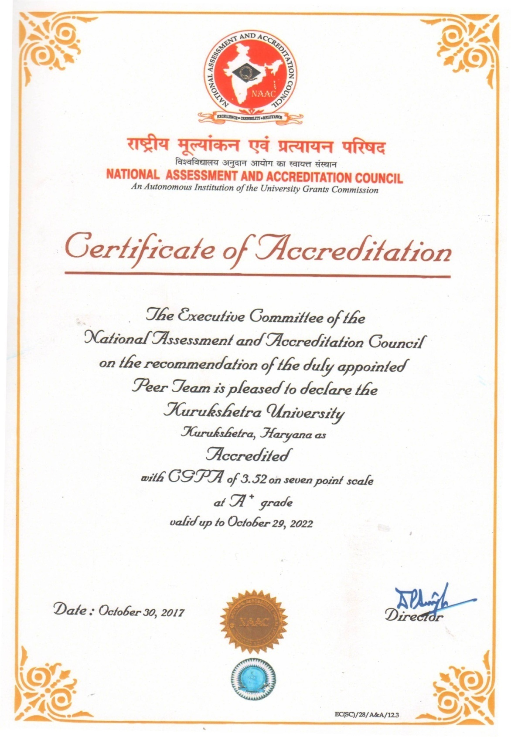
The University Library has rich resources mainly in Social Sciences, Humanities, Commerce, Management and Sciences. It is a centrally air conditioned three-storey building situated in the midst of the academic complexes of the University having a total collection of 323610 volumes (including manuscripts/theses/periodical etc.). The Library has an ERNET Centre at the first Floor with 160 Computers for the students and research scholars to access the available online resources. Access to 4,500 full text scholarly electronic journals from 25 publishers across the globe is available, under the UGC-INFONET E-journals Consortium in all the libraries and Departments through 900 Internet nodes. Bar-coding of books, computerization of library catalogue, automated circulation of books, OPAC database, Bar-coded ID and library Cards, Digital Library for E-resources—all have contributed to speedy retrieval and dissemination of information in the library.
INTRODUCTION TO THE SKILLS DEVELOPMENT CERTIFICATE/ TRAINING COURSES

The course contents of the skill based certificate courses are developed for enhancing the specific skills of diverse group including existing/old/dropouts students of college and university, those who are already in employment or seeking employment and those who wish to enhance their skills to become professionals.
To undertake the skill based training programme, it is mandatory that the candidate must fulfil the entry criteria provided for the job profile. The training and assessment will certify that the candidate is able to undertake specific set of activities. These certificate courses must not be equated with the formal qualifications- diploma/ degrees which are given by a University. These course take care of the Standards in accordance with The National Skills Qualifications Framework (NSQF), Ministry of Skill Development and Entrepreneurship,
to a large extent. A brief introduction to the various certificate courses run under RUSA Project by Kurukshetra University, Kurukshetra is given here.

COURSE CODE& Title: QM-1 PRACTICAL ASPECTS OF QUANTUM CHEMICAL CALCULATIONS: BASIC CONCEPTS

This certificate course will be beneficial for science graduates as it will enable them to keep pace with rapid advancements in the field of science and technology. It is highly important to familiarize our young workforce to leading and complex scientific fields. Research output will be increased and scholars will be in better position to develop quantum codes which may lead to several new start-ups and less dependency on software from aboard. Highly skilled professional in field of quantum chemistry will easily be absorbed in various Research Institutes and Research and Development division of leading corporations like IBM.
Entry Requirements: Completed/ Pursuing M.Sc. in Physical Sciences; Course Duration:120 Hrs. (15 days X 8 Hrs.) and the batch size is 20 candidates. The registration fee for this course is only Rs. 5000/ to be paid through Demand Draft in favour of Nodal Officer RUSA, KURPS payable at Kurukshetra.
COURSE CODE & TITLE: CLA: CHEMICAL LABORATORY ASSISTANT – BASICS

This certificate course is aimed to enhance the employability skills of all such candidates who are willing to serve as Chemical Laboratory Assistant in Schools,Colleges, Universities and Research institutions. Even those who are already working as Laboratory Assistants would acquire the appropriate skills required to perform their job effectively and efficiently. It is established fact that a chemical laboratory run by a skilled laboratory assistant will provide students with a better learning experience. A well-managed laboratory will facilitate the better utilization of funds. In addition, in such a favourable environment teacher will be in better position to get engaged with students in intensive discussions and scientific temperament of students can be improved. Hence, the certificate holders in chemical laboratory would have an edge over the others.
Entry Requirements: 10+2 pass (any discipline); Course Duration: 40 Hrs. and the batch size is 25 candidates. The registration fee for this course is only Rs. 500/ to be paid through Demand Draft in favour of Nodal Officer RUSA, KURPS payable at Kurukshetra.
COURSE CODE & TITLE: QC-QA: CERTIFICATE COURSE IN QUALITY CONTROL AND QUALITY ASSURANCE

Quality control and quality assurance is the most vital and almost inseparable parts of healthcare industry, healthcare product manufacturing, or even healthcare service providers. Proficient and effective QA and QC checks are much needed to ensure safe products in the market.Graduates of Quality Control and Quality Assuranceprogram can pursue careers in QA & QC, which is quiet essential parts of pharmaceutical, biotech and all other verticals of the healthcare industry. QA &QC are highly treated and most regarded divisions thus the career prospects and opportunities are never ending. The course has potential to employ candidates targeting to take over the quality assurance and quality control divisions of the industry as: Document Reviewer/Laboratory Analyst/Laboratory Chemist/Validation Chemist/Stability Chemist/Laboratory Technician/QC Analyst/Document Control etc. This course is exhaustive hands-on certificate course, which is suitable for student’s desires employment in the areas of pharmaceutical industry where physical and chemical techniques coupled with the state-of-the-art instrumentation are used for analysis of raw materials, in-process and finished products. The course includes training using the latest instruments and techniques like High Performance Liquid Chromatography (HPLC), tablet disintegration & dissolution, Infra-Red and Ultra Violet Spectroscopy. The course provides students the comprehensive knowledge and skills in the fields of Pharmaceutical Analysis, Quality Assurance and Regulatory Affairs. The courses provide the students with strong technical and practical skills needed by Quality Council of India (QCI) and Food Safety and Standards Authority of India (FSSAI) and US-FDA.
Entry Requirements:Diploma in Pharmacy or degree in Sciences (i.e. Pharmaceutical Sciences, Chemistry, Microbiology, Food Sciences etc). The final year students of graduation are also eligible for the course.; Course Duration: 50 Hrs. and the batch size is 20 candidates. The registration fee for this course is only Rs. 500/ to be paid through Demand Draft in favour of Nodal Officer RUSA, KURPS payable at Kurukshetra.

COURSE CODE: RS-1: CERTIFICATE COURSE IN RETAIL SALES SKILLS

The changing economic paradigm requires for a new market-oriented model of the sales process, as well as the modification of the behaviour of shop assistants. The main responsibility of a retail associate is to sell, rent, or lease a product or service to a consumer. Helping customers find what they are looking for is a large part of the selling process in any retail business. The retail associate may be selling anything from shoes, to wallpaper, to computer equipment. To be successful as a retail associate, it is important that the associate is able to accurately describe a product’s features, demonstrate its use, and show the styles and options available. This program is ideal for anyone planning to work at a retail business such as a grocery or clothing store. This course explores the Essential Skills required to work successfully in this field. The course is designed to develop interpersonal interaction and selling skills for effective employability in various retail sector organisations. Course will also focus on the developing the frontline salesforce for cross sectional jobs in the retail store. Sector specific batch may be given appropriate training in the concerned retail setup through a corporate tie-up preferably.

Entry Requirements: 10+2 pass (any discipline); Course Duration:Class room training for36 Hrs. and 6 weeks on the job training in retail stores. The batch size is 30 candidates. The registration fee for this course is only Rs. 500/ to be paid through Demand Draft in favour of Nodal Officer RUSA, KURPS payable at Kurukshetra.
COURSE CODE: CGD-1: CERTIFICATE COURSE IN GRAPHIC DESIGN- BASIC

Many employing graphic design skills work in a communications and marketing role. Technically, graphic design is visual communication.The field formally incorporates creative and function understanding of seven elements into its own form of communication: space, texture, colour, line, size, form, and shape.Graphic designers have to articulate ideas to companies, clients, employers, etc. It requires strong public speaking skills for presentations and writing skills for proposals. While many in graphic design do complete a college degree, it is not required. You will, however, need to demonstrate your graphic design skills beyond what is listed in your resume. Thus, the course in graphic design is aimed to provide well rounded and comprehensive training about graphic design so as to prepare skilled graphic designers for the industry. This certification is likely to give reach to the skilled persons in Television Industry, Publishing House, Newspaper & Magazine, Packaging Industry, Multimedia Companies, Education Centres& E-Learning, etc.
Entry Requirements: 10+2 pass (any discipline); Course Duration:41 Hrs. The batch size is 30 candidates. The registration fee for this course is only Rs. 500/ to be paid through Demand Draft in favour of Nodal Officer RUSA, KURPS payable at Kurukshetra.

COURSE CDM-1: CERTIFICATE COURSE IN ONLINE FACTS CHECKING & DIGITAL MEDIA SKILLS
In this course You’ll experience best practices for telling stories to an online audience —through social media, on the web, and to a mobile audience. You’ll learn to engage with video, digital photography, audio recordings, and data visualizations. You’ll have the tools and storytelling skills to produce, edit, and post content. Upon completion of this program, participants will have the knowledge and tools necessary to apply their new skill set immediately to their profession. It will help in knowing best practices for shooting, editing and producing videos, Learning to produce engaging content for digital platforms and learning to create interactive data visualizations, charts, graphs, and maps to tell stories. On completion of the course, you will have opportunity to serve in Print media, digital media, and advertising, printing & packaging Industry.
Entry Requirements: 10+2 pass (any discipline); Course Duration:40 Hrs. The batch size is 30 candidates. The registration fee for this course is only Rs. 500/ to be paid through Demand Draft in favour of Nodal Officer RUSA, KURPS payable at Kurukshetra.

Skill Development Cell Officials
Officials | Name of Official | Mobile
Nodal Officer RUSA | Prof. Manjula Chaudhary | 9896001727
Convener: Skill Dev. Cell | Prof. B. S. Bodla | 9466174087
Coordinator: Chemical Lab. Assistant; Practical Aspects of quantum chemical calculations | Dr. Sangeeta Saini | 9416979650
Coordinator: Quality Control and Quality Assurance | Dr. Sukhbir Singh | 9991226086
Coordinator: Retail Sales Skills | Dr. Rajan Sharma | 9813055116
Coordinator: On Line Facts Checking and Digital Media Skills and Graphic Design | DR. Ashok Sharma | 9813155366

Admission schedule, eligibility & other details about the Skill Development Courses.

Course Name | Eligibility  (Minimum) | Intake | Last date of application  Submission | Display of merit List for admission | Dates for Deposit of registration fees | Commencement of course
Chemical Laboratory Assistant | 10+2 & above | 25 | 31-10-2019 | 05-11-2019 | 6-11-2019 to  11-11-2019 | 15-11-2019
Practical Aspects of Quantum Chemical Calculations: Basic Concepts | M.Sc. Physics., Chemistry and allied | 20 | 31-10-2019 | 05-11-2019 | 6-11-2019 to  11-11-2019 | 15-11-2019
Quality control & quality assurance (QC-QA) | Diploma or Degree in Sciences or Pharma | 20 | 31-10-2019 | 05-11-2019 | 6-11-2019 to  11-11-2019 | 15-11-2019
Graphic Design | 10+2 & above | 30 | 31-10-2019 | 05-11-2019 | 6-11-2019 to  11-11-2019 | 15-11-2019
Online Facts Checking and Digital Media Skills | 10+2 & above | 30 | 31-10-2019 | 05-11-2019 | 6-11-2019 to  11-11-2019 | 15-11-2019
Retail Sales Skills (BATCH- 1) | 10+2 & above | 30 | 31-10-2019 | 05-11-2019 | 6-11-2019 to  11-11-2019 | 15-11-2019
Retail Sales Skills (BATCH -2) | 10+2 & above | 30 | 31-10-2019 | 05-11-2019 | 01-01-2020 to  08-01-2020 | 10-01-2020

Important Instructions:
- The interested students are required to download the application forms from the KUK website.www.kuk.ac.in
- Interested applicants have to download application form from the KUK website (www.kuk.ac.in) and submit duly filled in form in the office of the Convener-Skill Development Cell (RUSA) i.e. Institute of Management Studies, Kurukshetra University, Kurukshetra. Or the same can be emailed at director.ims@kuk.ac.in, and as per schedule given in the brochure.
- The merit list will be prepared on the basis of the marks of qualifying examination and the same will be displayed on the university website. Therefore, all the applicants are required to check the university website on a regular basis for the necessary information related to the admission to the course. No separate communication would be sent in this regard.
- The course would be conducted in the respective departments/institute of the course coordinators.
- No tuition fees will be charged for the skill development course except the nominal registration fees. The registration fees will be accepted by way of demand draft in favour of Registrar, Kurukshetra university, Kurukshetra as well as through online mode, at the time of commencement of the course.
- For any further query, the respective course coordinator can be contacted.
- The terms and conditions of the course are subject to change if needed by the university. And the information in this regard would be put on the university website as and when required.

KURUKSHETRA UNIVERSITY RUSA PROJECT SOCIETY
Admission Application Form
Paste your photograph
Centre for Skill Development Short-Term Courses

Important Instructions: Interested applicants have to download application form from the KUK website (www.kuk.ac.in) and submit duly filled in form in the office of the Convener-Skill Development Cell (RUSA) i.e. Institute of Management Studies, Kurukshetra University, Kurukshetra. Or the same can be emailed at coordinator.skilldevp@kuk.ac.in as per schedule given in the brochure. | (To be filled by office)  Application Form No ___________  Date of Receipt________________  Signature of the Official__________

1.
Name of the Course:
Name of the Department/Institute:

2.
Candidate’s Name |  | Date of Birth
Father’s Name |  | Gender
Mother’s Name |  | Nationality
Phone/Mobile no. |  | Email id
Bonafide resident of Haryana |  | Reservation category
Aadhaar No.

3.
Details of Educational Qualifications:
Examination Passed | University/  Board | Year of Passing | Subject(s) | Roll No. | Marks obtained/ Total Marks | %age of marks | Division

4.
Permanent Address: Correspondence Address:

** Applicants have to deposit the enrollment fees as notified in the merit list.

5. Are you employed? (pl. tick √ )
YES
NO
6. Have you ever been expelled/rusticated/punished on account of misconduct/indiscipline by any Institution?
YES
NO
NO
7. Are you enrolled in any other course in K.UK?
YES
8. Are you studying in any other course in K.U.K.?
YES
NO

Declaration by the Applicant and his/her Father/Guardian
I declare that entries made by me in this Admission Application Form are true in all respects and in any case, my information is found to be false, this shall entail automatic cancellation of my admission besides rendering me liable to such action, as the university may deem proper.
I note that my admission to the university and my continuance on its rolls are subject to the provisions/rules of the University, issued from time to time. I shall abide by the rules of discipline and proper conduct. I am fully aware of the law regarding ragging as well as the punishment and that if found guilty on this account I am liable to be punished appropriately.
I undertake that I shall not indulge in any act of ragging.

Dated:
Place: Signature of the Father/Guardian Signature of the Applicant

Following documents are attached with Admission Form
- DMC of Qualifying Examination
- Aadhaar Card/DOB proof.

Dated:
Place: Signature of the Applicant

