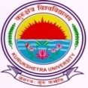
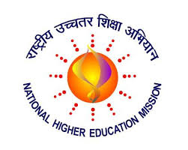
KURUKSHETRA UNIVERSITY RUSA PROJECT SOCIETY

Kurukshetra University RUSA Project Society invites applications for following Short term courses in Centre for Skill Development under RUSA 2.0.

Opening date for submission of applications: 12.10.2019

Closing Date for submission of applications extended upto: 15.12.2019

Certificate Course Name | Eligibility | Intake
Heritage Walks and Entrepreneurship In Heritage Tourism | Graduation | 30

NODAL OFFICER RUSA

