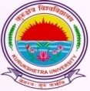
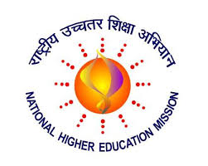
KURUKSHETRA UNIVERSITY RUSA PROJECT SOCIETY

Kurukshetra University RUSA Project Society invites applications for following Short term courses in Centre for Skill Development under RUSA 2.0.

Opening date for submission of applications: 12.10.2019

Closing Date for submission of applications extended upto: 07.11.2019

Certificate Course Name | Eligibility | Intake
Chemical Laboratory Assistant | 10+2 & above | 25
Practical Aspects of Quantum Chemical Calculations: Basic Concepts | M.Sc. Physics., Chemistry and allied | 20
Quality Control &Quality Assurance (QC-QA) | Diploma/Deg. in Sciences or Pharma | 20
Graphic Design | 10+2 & above | 30
Online Facts Checking and Digital Media Skills | 10+2 & above | 30
Retail Sales Skills | 10+2 & above | 30
Refer to Kurukshetra University, Kurukshetra website www.kuk.ac.in for more details.

NODAL OFFICER RUSA

