INSTRUCTIONS/GUIDELINES

FOR ADMISSION TO VARIOUS COURSES FOR THE SESSION

2021-2022

KURUKSHETRA UNIVERSITY, KURUKSHETRA
(Established by the State Legislature Act- XII of 1956)
(“A⁺” Grade, NAAC Accredited)
Website:- www.kuk.ac.in

KURUKSHETRA UNIVERSITY KURUKSHETRA
(Established by the State Legislature Act- XII of 1956)
(“A⁺” Grade, NAAC Accredited)

To
- All the Chairpersons/Directors of University Teaching
Departments/Institutes, Kurukshetra University
- The Principals/Directors of all the Colleges /Institutes affiliated
with Kurukshetra University
Subject:- Instructions/Guidelines for Admission to various Courses for the Session 2021--22 Submission of Registration Return thereof.
Dear Sir/Madam,
The Academic Session 2021-22 has commenced with admissions to various UG/PG courses from 06.09.2021. The admissions are required to be made strictly according to the provisions of the rules as contained in respective Ordinance(s), the instructions already issued from time to time, and the instructions uploaded on University website www.kkuk.ac.in by the Deputy/Assistant Registrar (Academic) vide his letter No. ACR-2/9/(viii) 21/15329-15409 dated 11.08.2021. However, the main instructions relating to admissions for various courses and submission of Registration Returns thereof to the University are being sent herewith.
Note : The changed schedule, if any, due to COVID-19 will be notified separately. The changed schedule will be uploaded on the University Website. The Principals/Directors/Chairpersons/candidates are requested to remain in touch with the University Website regularly.
The main points of these Instructions/Guidelines be incorporated in the Prospectus of the College/Department (in case, the Prospectus is published separately by the Department itself). In addition, a copy of these Instructions/Guidelines be also displayed on the Notice Board of the College/Department for information of the students and for wide publicity.
Nothing contained in this letter would be construed to convey sanction or cited as an authority for which University Regulations in Calendar Volumes-I, II and relevant rules in Volume-III alone are applicable.
You are, therefore, requested kindly to get the Registration Returns prepared accordingly after admissions and send the same to this office, duly checked and authenticated, within the schedule of time fixed for this purpose.
Specimen of Blank Registration Return Forms alongwith other relevant Proforma attached can be downloaded from our Website www.kuk.ac.in
Yours faithfully,
Sd-
Assistant Registrar (Regn.)
For Registrar
Encl:- Detailed Instructions/Guidelines
(From Page- 1 to 42)
Specimen Regn. Return Proforma
(From Page- 43 to 64)
Contd…p/2…
Endst.No. Regn/R-I/2021/441-455 Dated: 14/10/2021
A Copy of the above is forwarded to the following for information and necessary action:-

- Director Higher Education, Haryana, Shiksha Sadan, Sector-5, Panchkula.
- Director, Technical Education, Haryana, Panchkula.
- Dean Academic Affairs, KUK.
- Dean of Colleges, KUK.
- OSD to the Vice-Chancellor, KUK.
- Finance Officer, KUK.
- Asstt/Deputy Registrar (S.C. Cell), KUK
- Assistant Registrar (Academic), KUK.
- Deputy/Asstt. Registrar (R-I), KUK.
- Asstt. Registrar (R-II), KUK.
- Asstt. Registrar (R-III), KUK.
- Superintendent O/o the Registrar (for kind information of the Registrar), KUK
- PA to the Hon’ble Vice-Chancellor/Controller of Exams-I&II./Director, Distance Education (for kind information of the Vice-Chancellor/Controller of Exams./Director, Distance Education), KUK.
- Superintendents (Colleges) (I & II), KUK.
- All the dealing Assistants (Regn. Branch), KUK

Assistant Registrar (Regn.)
for Registrar

KURUKSHETRA UNIVERSITY KURUKSHETRA

- GENERAL INSTRUCTIONS/GUIDELINES FOR ADMISSION TO VARIOUS COURSES
 |  | ADMISSION COMMITTEE AND ADMISSIONS
1 |  | Every College/Department/Institute shall constitute an Admission Committee to be appointed by the Principal/Chairperson from amongst the teachers of the College/Department and SC/ST representative must be included in the Admission Committee.
All the admissions should be made by the Department/College/Institute through the Admission Committee to be constituted strictly in accordance with the rules as contained in the Ordinance for the relevant course/class appearing in the University Calendar Volume II, 2014. Notifications regarding provisions of relevant Ordinance(s) for Under-Graduate and Post-Graduate Classes/Courses as well as subsequent amendments circulated by the University from time to time be kept in view.
If any wrong/irregular/ Ineligible/excess admission without finalization of eligibility is made and such ineligible students appears the Examination the entire responsibility will rest upon the Principals/Chairpersons of the Colleges/Departments concerned.

A certificate from each student seeking admission to the effect that any University/Board has not disqualified him/her, must invariably be obtained at the time of admission. Certificates/ Detailed Marks Cards of all such students seeking admission on having passed the qualifying examination from other Universities/Boards may categorically be checked exhaustively at the time of admission and it may also be ensured that the candidate seeking admission is eligible. If there is any doubt, regarding Equivalence of University/Board/Course, a clarification to this effect must be sought from the Asstt./Dy. Registrar (Academic ) before the finalization of admission.
2. |  | ALLOCATION OF SEATS:
Admission of students in no case should exceed the sanctioned strength of each Class/Course. However, Instructions regarding additional seats circulated by Academic Branch time to time may be kept in view while making admission.
Admissions allowed in excess of the sanctioned strength will be the sole responsibility of the Principal/Chairperson/Director of the College/Department/Institute concerned and the University will take strict action for allowing wrong/excess admission.
The Dean Academic Affairs and the Dean of Colleges will exercise control and supervise the admissions in the UTDs and in the Colleges affiliated with this University respectively. A copy of the details showing sanctioned strength of each class/course/subject be prepared on format RF-10A (with photocopy of affiliation letter) by the Principal/Chairperson/Director and required to be sent along with the Registration Returns. Any delay in this regard will be viewed seriously. Admissions of students be made only in such class/course/subject where permission/affiliation has been granted by the Colleges Branch of this University. In case admissions to any fresh class/course is/are made, Registration Return with a copy of approval for affiliation be sent with Registration Returns failing which Registration Returns will not be entertained.
3 |  | RECOGNITION OF EXAMINATION
Complete information regarding Recognition/Equivalence of examinations of other Universities/Institutes /Boards and the rules of Equivalence for higher studies at this University are available in the Book of Equivalence of Kurukshetra University and the same has been displayed on K. U. website i.e. www.kuk.ac.in. However, in a particular case where equivalence of examination of any University/Institute has not been considered so far, the eligibility of such case can be finalized for the purpose of higher studies, keeping in view the terms and conditions given under Note No. 41 & 42 or 44, as the case may be, appearing at page : 316-317 of the Book of Equivalence.

10+2 level Examination of various States/Boards of Education recognized by the Kurukshetra University, Kurukshetra for the purpose of Higher Education, lists in the Book of Equivalence be treated as recognized having passed with five subjects including subject of English.

A list of de-recognized Board/ Universities and fake Universities as circulated by the UGC is attached for your ready reference. However, updated list can be downloaded from the UGC website i.e. www.ugc.ac.in . An updated Book of Equivalence of ( Indian/ foreign) Examination is available with the Manager ( P & P), K. U. Kurukshetra which can be obtained on payment, the same has also been displayed on KU website.
 |  | Bihar School Examination Board, Patna has been recognized by this University subject to checking and verification of the certificate issued by that Board.
As far as the admission on the basis of having passed various diplomas/vocational courses, mere recognition of any examination be not taken as proof of granting admission to any candidate in any Course/Class, eligibility conditions prescribed in the respective Ordinance(s) must strictly be adhered to.

To avoid unnecessary delay, the Registration Branch/ Department/Institute/College/Examination Branch may finalize the eligibility at their level.
 |  | ELIGIBILITY
4. |  | Eligibility of students who have passed their qualifying examination from Board of School Education, Haryana/other Boards/Universities including Kurukshetra University, be checked properly and admissions be allowed in accordance with the provision of rules of the Ordinance concerned. The particulars of the candidate i.e. Name, Father’s Name, Mother’s Name should strictly be the same as mentioned on the qualifying examinations and their Registration Return must reach in the Registration Branch as per schedule alongwith legible photocopies of the certificates of the qualifying examination, duly attested by the Principal of the concerned College himself/herself and/or by a teacher deputed for the purpose.
Candidate(s) placed under compartment in one subject only can be admitted provisionally to Part-I of B.A./B.Sc./B.Com./BCA/BIM/BTM at his/her own risk/responsibility subject to passing their compartmental subject before commencement of the Examination of 1st semester of the year as per provision of rules, contained in the respective Ordinance.
Admissions of all such cases will be subject to their fulfillment of the minimum eligibility conditions. Registration Returns of all such cases be sent on Format RF-4/4A and the same must be accompanied by legible photocopies of the lower qualifying examination, duly attested by the Authority as detailed above. For regularization of admission of such students, photocopies of the certificates, duly attested, of the examination passed by the candidate(s) in supplementary examination, be sent, in person, to this office immediately after the declaration of the result but before the commencement of examination of 1st semester of the year as the case may be.

** 3-year diploma course examination conducted by various State Boards of Technical Education in India, which are recognized by the Director, Technical Education Haryana, Chandigarh be recognized as equivalent to +2 level examination for admission to 1st year of 3-year Bachelor Degree Course at this University, provided the candidate shall pass the subject of Hindi Core of +2 level examination, if not already pass at the supplementary examination only of the same year of admission.

Compartmental candidates are not eligible for admission to various P.G. Professional/Tech./Medical/Para-medical Courses. Therefore, all such requests may not be considered at all. Concerned Ordinances be kept in view while making admissions. However for other P.G. courses (in affiliated Colleges only) students having re-appear in only one paper either in 5th OR 6th Semester at Under-graduate level other than the subject/paper in which he/she has sought admission in Post-graduate Course (s) may be allowed to seek admission in any Post graduate course (s) subject to the condition that they will not be allowed promotion in the 3rd Semester of Post-graduate Course, if they fail to pass the concerned one paper of their graduation before the commencement of the 3rd Semester and their provisional admission in the P.G. Course will be cancelled. However, students who have clearly passed graduation have to be considered for admission first and thereafter for remaining seats reappear candidate are to be considered.

 |  | All the Chairpersons/Directors of UTDs/Institutes/ Principals/Directors of all the Colleges /Institutes affiliated with Kurukshetra University concerned are requested to:
 | i) | Ensure that ineligible candidate(s) is/are not allowed admission in the College/Dept./Instt. and for this every precaution must be taken. Responsibility for any wrong/irregular admission or admission allowed on the basis of fake certificate or promotion allowed to next higher class without registration number, in contravention of the Ordinance, if any, will rest entirely with the Principal/Chairperson/Director of the College/Department/ Institute concerned, admission of such students may be treated as cancelled ab-initio and necessary steps will be initiated against the college as per University rules. In case any student files civil suit in any Judicial Court against the orders declaring him/her ineligible, the said civil suit is required to be defended by the College/Department/Instt. concerned and in case it is to be defended by the University, the expenses incurred on the said civil suit will have to be born by the College/Department concerned.
 | ii) | While deciding the CWP No.16591 of 2001 – Mr. Bhupesh Gupta, resident of Naraingarh (Ambala) Versus Kurukshetra University and others, the Hon’ble High Court at Chandigarh has observed that the University should take steps to ensure that the educational institutions strictly follow the eligibility criteria while granting admission to the students and not play with the career of young men/women just for their own financial gains. Therefore, all the Principals/Chairpersons/Director of the Colleges/Deptts., especially the Principals of the professional Colleges, be directed to be more vigilant and consider only those students, who are eligible for admission to the Course/Class and his/her admission is as per provision of rules contained in the concerned Ordinance.  The above mentioned decision of the Hon’ble High Court should be strictly adhered to in letter and spirit.  RULES REGARDING THE ADMISSION OF EASTERN INSTITUTE FOR INTERGRATED LEARNING IN MANAGEMENT, UNIVERSITY AND CMJ UNIVERISTY, MEGHALIYA IS AS UNDER:  - The candidates who have passed their qualifying examination from EIILM University through Regular mode ( who submitted the proof of regular course of EILLM University, Sikkim at the time of admission) if otherwise eligible, may be considered for admission in the course.  - The candidates who have passed their qualifying examinations from EILLM University, Sikkim through Distance mode or whose mode has not been mentioned, and who have not submitted any proof/information regarding the mode of passing the qualifying examination from EILLM University, Sikkim at the time of admission may not be considered for admission in the course.  - Regarding the CMJ University, the Academic branch has already circulated the notification Endst. No. ACM-11/ Mics.30146-30205 dated 29-7-2013, issued by the Principal Secretary to the Governor of Meghaliya.  ADMISSION CONCESSIONS FOR COLLEGES/INSTITUTES AFFILIATED WITH THE KURUKSHETRA UNIVERSITY FOR UNDER-GRADUATE AND POST-GRADUATE COURSES FOR THE SESSION 2021-22.  - In addition to the sanctioned seats, additional seats for the following categories will be as under :  - Two additional seats in P.G. courses including Law (3 Yr.) & Integrated courses and 10 seats in Arts, 05 seats in Science and 05 Seats in Commerce in TDC Part-I over and above the sanctioned seats for the outstanding sports persons (except the courses in which admissions are being made by the Haryana State Counseling Board/A.I.E.E.E.) w.e.f. the session 2018-19 as per the following criteria :  (i) NORMS, GUIDELINES & CRITERIA TO DECIDE THE MERIT FOR OUTSTANDING SPORTS PERSON FOR 2 ADDITIONAL SEATS IN P.G. COURSES INCLUDING LAW (3 YR.) & INTEGRATED COURSES  Norms For Outstanding Sports Person : Outstanding Sports Person means a person who has atleast represented the University or State in the Inter University or Senior National Level Championship or above. This include (Senior National, Federation Cup, National League, Inter Zonal National, National Games/National University Games during the course of his/her Graduate/Post Graduate studies).  Guidelines for Sports Seats  Sports Certificate for admission will only be considered, if the candidate produce the Gradation Certificate from the respective Govt. in respect of the game/sports for which the candidate claim outstanding sports person seat  In case any state does not issue the Gradation Certificate, the following criteria will be adopted :  - In case of International/National participation or Position Holder, a certificate of authenticity will be required from concerned National Federation/State Association.  - In case of Inter University Participation or Inter University Position Holder other than Kurukshetra University, a certificate of authenticity from the Head of Sports of the concern University will be required.  - The game/event must be in the scheduled list of Association of Indian University Sports Calendar.  - The tournament must be organised by recognised Federation/Association duly affiliated with State Olympic Association/Indian Olympic Association and Ministry of Youth Affairs & Sports.  - Achievement during the course of Graduate and Post-Graduate studies will be considered for admission in Post-Graduate courses including Law (3 Year).  - No sports achievement lower than the above will be considered for admission for outstanding sports person category, even if the seats remain vacant.  Criteria to decide the Merit  - In case of tie in the sports achievement level then the maximum number of achievements at the same level of the minimum eligibility under sports criteria will be taken into account for deciding the merit.  - In case Entrance test to be conducted, then the marks obtained Entrance test in the Qualifying Exam. will be considered for deciding the merit.  - If still there is tie, then marks obtained in the Qualifying Exam. will be considered for deciding the merit.  - If still there is tie, then the age will be considered for the merit (Higher in the age will be considered for the merit).  No weightage will be given for participating/winning positions in the sports and games organised by Nehru Yuva Kendra, CBSE Nationals /Vidya Bharti Nationals /Rural Tournaments /Panchayat Tournaments /Novaodya Nationals and invitation non-recognised tournaments/sports festivals.  NORMS, GUIDELINES & CRITERIA TO DECIDE THE MERIT FOR 10 SEATS IN ARTS, 05 SEATS IN SCIENCE AND 05 SEATS IN COMMERCE FOR OUTSTANDING SPORTS PERSONS IN T.D.C. PART- I & TWO (02) SEATS IN INTEGRATED COURSES  Norms For Outstanding Sports Person : Outstanding sports person means a person who has atleast participated in School Nationals/Junior National/Youth National/National School Games in [under 19/17 (nineteen/ seventeen) year Age Group] or above in the preceding three years.  - One additional seat in all courses will be for NCC cadets who have attended the Republic Day (R.D.) Parade and Camp over and above the sanctioned seats.  - One additional seat in all courses will be for NSS Merit Certificate holders who have attended the Republic Day (R.D.) Parade and Camp over and above the sanctioned seats.  At the time of admission Principal of concerned College will ensure  Authenticity of the Sports Certificate
5. |  | ELIGIBILITY FOR FOREIGN STUDENTS
Foreign Candidates have to obtain eligibility certificate from the University prior to consideration of their cases for admissions. In no case the College/Department shall admit any foreign candidate without production of Eligibility Certificate which will be issued by the Asstt./Dy. Registrar (Registration).

ADMISSION RULES AND PROCEDURE FOR INTERNATIONAL STUDENTS

These rules define the procedure for the admission of international students to various courses of Kurukshetra University, Kurukshetra. These rules are based on General Guidelines issued by the University Grants Commission (UGC), Association of Indian Universities and Statutory/Regulatory directives issued from time to time.

The Office of Advisor, International Student shall provide necessary guidance for admission of foreign students to the various courses run in the University. All correspondence related to international students should be addressed to the Office of the Advisor, International Students, Kurukshetra University, Kurukshetra – 136119 (Haryana) India.

International Students
(i) Foreign Student: Students holding passports issued by foreign countries including Persons of Indian Origin (PIO) who have acquired the nationality of foreign countries.
(ii) Persons of Indian Origin (PIO): PIO shall mean the Persons who are citizens of other countries (except Pakistan and Bangladesh) who at any time held an Indian Passport, or who or either of his parents of any of his grandparents was a citizen of India by virtue of the provisions of the Constitution of India or Sec 2 (b) of Citizenship Act, 1955 (Act No. 57 of 1955).
(iii) Non-Resident Indians (NRIs): Only those Non Resident Indian students who have studied and passed the qualifying examinations from schools or colleges in foreign countries will be treated as international students. This will include the students studying in the schools or colleges situated in the foreign countries even if affiliated to the Boards of Secondary, Higher secondary Education or Universities located in India, but will not include students studying in those schools and colleges (situated in India) and affiliated to the Boards Secondary Higher Secondary examinations from Boards or Universities located in foreign countries as external students and Dependents of NRI studying in India will not merit the status of international Students.

Documents required for admission of international students
- VISA: All the international students shall require a student VISA endorsed to the Kurukshetra University, Kurukshetra for joining the full time courses. Foreign students admitted to Kurukshetra University shall obtain a STUDENT VISA in the name of Kurukshetra University on the basis of admission within one Month from the date of admission for the prescribed duration of the course. A copy of this VISA is to be submitted in the office of Advisor, international Students, Kurukshetra University Kurukshetra.

(ii) Certificate from Association of Indian Universities (AIU): The course on which eligibility is relied upon must be included in the list of the Association of Indian Universities (AIU). In case the University/Board is not included in the said list, the candidate has to obtain and submit Equivalence Certificate to this effect from the Association of Indian Universities.

Submission of Equivalence Certificate from AIU is mandatory for foreign nationals. The AIU address is given below:
The Secretary General
Association of Indian Universities
AIU House, 16, Comrade Indrajit Gupta Marg
New Delhi-110002
Phone No. (91) – 11-23230059; (91) – 11-23232429
Fax No.(91) – 11-23232131
E-mail: aiu@dell2.vsnl.net.in
Website: http://www.aiuweb.org

(iv) Attestation by concerned Embassy/High Commission/Consulate: All attestation must be done by the concerned Embassy/High Commission/Consulate of the relevant country in India. The document without attestation shall be summarily rejected.

(v) Attested Transcripts: Candidate applying from their own country should get their transcripts of certificates attested by the concerned accredited authorized Government Agency and also duly certified by the Indian Embassy or Consulate as the case may be Attested copies of Senior School Certificate/Bachelor’s Degree/Master’s Degree or equivalent thereof should be attached.

(vi) Character Certificate: A Character Certificate from the Head of the Institution last attended alongwith its attestation by the concerned Embassy/High Commission/Consulate should be submitted.

(vii) Medical Certificate: All the international students have to undergo the medical examination and get the medical fitness certificate. As per government rules all international students entering India on student visa have to be tested for HIV and will not be given admission if found to be positive.
(viii) Registration in Foreign Regional Registration Office (FRRO) : Within 14 days of arrival in India, the international student has to register his name with the police in the Foreigner Regional Registration Office (FRRO) of the local police. For this the following documents shall be submitted by the admitted students to the Office of the Advisor, International Students :
a) Photocopy of the Passport
b) Photocopy of the VISA
c) Proof of Residence
d) Proof of Admission
e) Four Passport Size photographs
f) HIV Report.

5. Eligibility Qualifications: International students should fulfill the minimum eligibility condition prescribed for admission as per the requirements of the course applied for. HOWEVER, such candidates shall NOT be required to undergo the admission entrance test.
6 |  | SENDING OF DOCUMENT
 |  | As no original documents except Migration Certificates are to be sent along with the Eligibility Forms/Registration Returns, strict vigilance may be exercised by the College/Department concerned about the genuineness of the DMCs/Passing Certificates/Degrees and other relevant record produced by the candidate(s) and in case of doubt, it should be got verified from concerned Board/University, if found fake, the same be dealt with accordingly and such candidates should be debarred from admission ab-initio
7 a |  | ADMISSION OF THOSE CANDIDATES WHOSE RESULTS OF QUALIFYING EXAMINATION ARE DECLARED LATE:  The Principals of the Colleges will make provisional admission of their students (already registered with this University) in promotional classes of B.A./B.Sc./B.Com./M.A./M.Sc./M.Com. etc. On declaration of the result, if a student fails, his/her provisional admission shall stand cancelled ab-initio.
8. | b  c  d | No students from outside/other colleges/departments/private candidate/distance education student may be granted admission to promotional classes of B.A./B.Com./B.Sc. UG/PG Professional/ M.A./M.Com./ M.Sc. etc.  The Principals/ Chairpersons/ Director of the Colleges/Departments/Institutes concerned will allow provisional admissions to their own students who are already registered with this University and whose result of Under-graduate/Post-graduate Examinations are not yet declared by the University except UMC cases.  The Chairperson/Director/Principal of the University Teaching Depts/Institutes Affiliated Colleges are requested to submit the late admissions/ promotional cases with details on RF 13 performa for admission to various courses are being run in the University Teaching Depts/Institutes affiliated Colleges.  Permission for joining late shall not be accepted as a justification for condoning deficiency in lectures. Provided that in case of a candidate who is allowed late admission as a result of any change in the Rules/Admission Policy made by the University, the lectures shall be counted from the date of admission or from the 11th day of the date on which the decision to change the results/admission policy is taken, whichever is earlier.  Provided further that in the case of a candidate who joined late owing to late declaration of result or who sought admission provisionally till the declaration of the result of the lower examination, the lectures etc. shall be counted from 15 days after the declaration of the result or the date of his joining whichever is earlier (kindly see Clause 11 of the Ordinance – V printed at Page-24-25 of the University Calendar Volume-I, 2009).  The shortage of lectures be notified at least thrice during the session by the Principals.  If a student fails to attend his/her classes continuously for seven days from the date of commencement of the classes or from the date of admission, his/her admission shall be cancelled.  If a student remains absent from the class for 14 days or more in a month, his name will be struck off from the rolls and his/her parents will also be informed.  An Official E.Mail ID will be allotted and communicated to every regular student by the concerned Colleges/Institutes for sending Official Communication to him/her.  PROMOTION TO NEXT HIGHER CLASS
9. |  | Students of Post-Graduate Courses including LL.B.3 year, LL.M. and professional courses like BHM&CT, MBA-5 year, MBA(Hons.), LL.B.-5 years, B. Pharmacy etc. who are deficient in clearing 50% papers of their previous class(s) may be allowed to join the next higher class with an additional fee of Rs.500/- per deficient paper payable to the University.  All students will be admitted by the College/Department provisionally at their own risk and responsibility after obtaining undertaking in writing from the students. This undertaking must be got printed in the College Admission Form in the following form:-  “I solemnly declare that the information detailed by me in the Admission Form is correct to the best of my knowledge and belief and nothing has been concealed therein. I also do undertake to abide by all the rules, regulations and instructions of the College and also of the University. I am taking admission in the College provisionally at my own risk and responsibility subject to confirmation of my admission by the University. If, at any stage, I am declared ineligible and my admission is cancelled by the University ab-initio, I will abide by the orders of the University and forego every right to claim for it.”
10. |  | COMBINATION OF SUBJECTS
 |  | The combination of subjects offered by a candidate must be checked carefully with the provisions of the rules as contained in the relevant Scheme of Examinations before his/her admission is finalized. The responsibility of having allowed wrong combination of subjects/papers to a candidate will rest entirely with the Principals/Chairpersons of the Colleges/Departments concerned.
 |  | ENGLISH AT QUALIFYING EXAM.
11. |  | The candidates who have passed the qualifying examination from other Universities/Boards without English are not eligible to seek admission to various Under-Graduate Courses, as a regular student irrespective of the fact that their qualifying examinations stand recognized in the Equivalence Book.
Hindi AT QUALIFYING EXAM

3-year Diploma for admission to three year Bachelor degree courses, provided the candidate shall pass the subject of Hindi(Core) of +2 level if not already passed at supplementary Exams. only of the same year of Admission

CONCESSION FOR THE STUDENTS SEEKING ADMISSION TO B.A./B.SC.(GENERAL) COURSES

 |  | A candidate of another University/Board who has passed 10+2 examination but did not pass in the subject of English or any one deficient subject as per requirement of the Ordinance in the Senior Secondary Certificate Examination of 10+2 standard of Board of School Education, Haryana or in any examination recognized as equivalent thereto may be allowed to join the B.A./B.Sc.(General) Part-I Class provisionally subject to his qualifying in the subject of English or deficient subject of 10+2 standard examination before the commencement of 1st semester’s examination failing which admissions of such students may be treated as cancelled ab-initio and the Principal of the College will be informed accordingly.
B. |  | INSTRUCTIONS SPECIALLY FOR PROFESSIONAL COURSES
12. |  | With regard to admissions in Professional Courses, the Principals of the Professional Colleges/Institutes affiliated with this University shall strictly follow the minimum eligibility conditions as laid down in the concerned Ordinance of this University. Admissions of candidates with less than minimum eligibility conditions will not be regularized by the University in any case.
 |  | Special attention should be given by the Directors/Principals of all the professional Colleges/Institutes while giving the admission and sending the Registration Return to avoid any legal complications at a later stage as University has to face very unpleasant situation on the wrong admissions made by the Institute/College. Hence, it is necessary to keep in mind the following points while making admissions and sending the Registration Return to the University.
 | (a)  (b) | In pursuance of the judgment of the Hon’ble Supreme Court in the case of P.A. Inamdar Vs. State of Maharashtra, AIR 2005 SC(3226), no admission be made henceforth against NRI Sponsored/industry seats as already notified vide this office Endst. No.ACM-3/Misc.06/17013-17072 dated 20.08.2007. NRI seats are to be filled up only from genuine NRI, their children and wards. In the Prospectus for the Session 2015-16 onwards, it should be clearly mentioned that seats earmarked for NRI category will only be filled up from the genuine NRI, their children and wards, as per direction of the Apex Court.  As per discussion of the meeting of State Admission and fee Committee held on 25.4.2006, Registration Return Proforma for professional courses have been prepared. Hence, Registration Return will be accepted only on these revised proforma complete in all respect.
 | c) | The Eligibility of all the students, even if they are admitted through Central counseling, should be checked by the College itself before the confirmation of admissions. Any excuse like admissions are made through Counseling etc., Wrong admissions pointed out by the University on the receipt of documents, will not be accepted and Principals/Directors of Colleges/Instts. will fully be responsible for any wrong admission.
C. |  | SOME OTHER GENERAL INSTRUCTIONS:
13. |  | All legal disputes relating to admissions of students will be subject to District Courts at Kurukshetra or Courts having jurisdiction at Kurukshetra.
14. |  | There shall be no rounding off percentage of marks from 0.5% and above to next higher number for determining the eligibility for admission to various courses (Ref. Academic: ACM-3/Admn.13(i)/14/4954-5093 dated 5.05.2014)  In case two or more candidates in the merit list have equal percentage of marks, the candidate senior in age will be considered first.  All admission application should accompany with all requisite documents/certificates for eligibility weightages, reservation and other concession, failing which such applications for admission will not be considered and finally rejected.
15.  16. |  | No course will be started if the strength of admitted students is less than ten, and no option will be started if the strength is less than five. All UTD/Colleges/Instt. Affiliated to KUK shall notify the options in each course with number of seats well before the admission and the options will be allotted on merit basis.  It may be ensured that the children of single parents are not denied admission in the College/Department on the plea that names of both the parents are not mentioned in the certificate of qualifying examination/admission form, if they are otherwise eligible/subject to fulfillment of all other conditions of admission. In view of Memo No. 11/24-97(UNP)(i) dated 28.1.2000, all such students seeking admission may not be insisted on recording the names of both the parents.
17. |  | The rates of fee/funds etc., shall be the same as prescribed by the University from time to time.
18. |  | The Principals of the Colleges are requested to include the following in the Prospectus to avoid confusion at later stage.
 | i) | Admissions in Colleges would be strictly on merit.
 | ii) | No separate intimation would be sent to the students. They would themselves be responsible for checking of the list displayed on the specified dates for admissions on Notice Board of respective colleges.
 | iii) | If any student whose name appeared in the merit list but did not deposit his/her fees in the fixed scheduled time would forego his/her right for admission and would not be reconsidered in any case.
 | iv) | Students be advised to apply simultaneously in more than one college in order to avoid disappointment.
 | v) | Students seeking admission in under-graduate courses on the basis of having compartment in one subject of 10+2 examination must clear his/her compartment subject before the commencement of examination of 1st semester of the year, as per provision of the concerned Ordinance. In case he/she does not clear the same, his/her admission shall be cancelled ab-initio. An undertaking to this effect must be taken prior to their admissions.
19. |  | No Inter-College Migration shall be allowed by the University unless the student has been registered in this University.
20. |  | No Inter-Varsity or Inter College Migration shall be considered during the Ist year of any Course or in the Course having one year duration.
21.  21a |  | During Course Migration from affiliated Colleges/other Universities shall not be allowed to this University Teaching Department/Institutes or vice-versa.  The existing practice of not allowing inter-College Migration in 1st year/Even Semester of a course may continue except in the case of transfer of guardian/marriage where migration in 2nd Semester may also be considered.
22. |  | Reservation Policy of the State shall continue to be followed as uploaded on University website by the Academic Branch as amended from time to time by State Govt. In case of any doubt, clarification may be sought from the Asstt./Deputy Registrar (Academic) of this University. Deviations in the implementation of the RESERVATION POLICY will not be tolerated and any lapse therein will be dealt with severely.  (a). Relaxation of the condition of eligibility :  - Unless otherwise specifically provided for a course in the concerned Ordinance, the eligibility condition for Scheduled Castes/ST/Differently abled candidates will be minimum pass marks in the qualifying examinations for admission to a course.  - In case where specific relaxation of 5% marks in the eligibility condition is to be given to SC/ST/Blind /Visually/Differently Abled etc candidates, the minimum less marks against 55%, 50% and 45% marks shall be calculated as under:-  55 marks -2.75 marks =52.25 marks (5/100x55=2.75);  50 marks -2.50 marks =47.50 marks ( 5/100x50=2.50);  45 marks -2.25 marks =42.75 marks ( 5/100x45=2.25);  - However, this relaxation is not applicable for LL.B. Professional-3 Yr. and B.A. LL.B. (Hons.)-5 Yr.
23. |  | If the last date for admission falls on a holiday or that day is declared a holiday by the University/College, the next working day will be considered as the last date for the purpose.
24. |  | The Principal of the College is permitted to admit the students after a gap of studies, if the student is otherwise eligible and his/her case falls under the admission policy.
25. |  | No student be allowed promotion to the next higher class without Registration Number. If Principal of concerned College allows promotion without Registration Number to any student, he/she will be responsible for this lapse and admission of such students may be treated as cancelled ab-initio.
26. |  | As decided in the meeting of the Principals of all the affiliated Colleges held on 17.5.2004 and communicated vides Endst. No.CBS/2004/4890-4963 dated 25.5.2004 no casual admission will be made in the Colleges. However, such students who have to appear in the Practical Examination may be admitted on casual basis in the beginning of the 2nd term i.e. in the month of September. Failure Science students cannot be admitted as casual students. The normal fee will be charged from the casual students as is being charged from the regular students.
27.  28.  29.  30  31  31-A  31-B |  | It may also be ensured that no regular student be allowed to appear in the examination of the University until and unless his/her Registration Return has been sent to the University.  In no case, the college should mention any clause in their prospectus which is in violation of University rules and ineligible candidate be not admitted in the College by the Principal. Any violation of the rules in admission will be personal responsibility of the Principal of the College and the Vice-Chancellor is authorized to impose penalty on College for admission of such students who do not fulfill the minimum qualification on case-by-case basis. (Ref. Admission Committee Res. 5 dated 21.05.2013).  Incomplete Registration Return or without complete documents shall be liable for late fee as per schedule till the Registration Return is completed in all respect.  The competent authority of the University may reconsider the case to revive/regularize/late submission of Registration Returns/migration/ inter college migration etc. on the merits of the case.  Schedule for accepting Registration Returns of all the affiliated Colleges/Institute/UTDS (Except B.Tech./M.Tech./UTDs CBCS Courses) will be as under:  - If, the Registration Returns will be uploaded through online University portal and the existing time period of submission of Registration Return to the University is reduced from 40 days to 15 days and in case of extended dates of admission, 03 days of the last date instead of 10 days. All the documents will be submitted within 20 days of the last date of admission.  - The process of uploading of data of Registration Return will be completed only after depositing the Registration fee/Continuation fee/Development fee/University Establishment Charges through a payment gateway.  - As well as a hard copy of Registration Returns may also be submitted to the University as per past practice to avoid the problem, if any arises, during the process of online submission of Registration Returns as online portal is being launched first time.  - If the Instructions/Guidelines for any session could not be issued in future due to administrative reason then the Instruction/Guidelines of pervious year will be applicable in toto.  Schedule for accepting Registration Returns of professional Colleges (B. Tech./M. Tech./ and UTDs CBCS courses) will be as under:  - The professional colleges/institutions/UTDs assigned to HKCL will upload the Registration Returns data online on HKCL server within 15 days from the last date of admission and will submit all the documents of admitted candidates with details within 20 days from the last date of admission. After 15 days, the portal will be closed and no registration return data will be uploaded thereafter.  - The process of uploading of data of Registration Return will be completed only after depositing the Registration Fee/Continuation Fee/ Development Fee through a payment gateway.  - HKCL officials will provide the Registration Returns in prescribed proformas college-wise as well as class-wise in excel form with a hard copy.  Schedule for accepting Registrations of B.Ed/M.Ed course will be as Under:  The Registration/Continuation Returns of B.Ed 1st year/2nd /M.Ed. 1st year/2nd year will be submitted within 15/40 days from the last date of last round of 1st counseling of B.Ed 1st year/M.ed 1st year.  Before the commencement of first semester/Ist year examinations, all the discrepancies will be got removed by the concerned colleges/institutions/UTDs, failing which Examination Roll No Slips of the concerned students will not be issued/generated and the student will not be allowed to appear in examination of first sem/year.  Schedule for accepting Registration Returns will be as under:  - Admission schedule be prepared by Academic Branch in consultation with the State Govt. Admission Agencies, who regulate/make admissions of the professional courses.  - (a) All the affiliated colleges/institutes and University Teaching Departments will have to submit the Registration Return/Continuations Return of only eligible students to the Registration Branch within 15/ 40 days without fine from the last date mentioned in schedule of admissions issued by the Academic Branch.  - All the affiliated Colleges/Institutes and University Teaching Department will have to submit the Registration Return of only eligible students to the Registration Branch within 3/10 days each of the extended last date of admission with late fee as fixed by the University from time to time.  - If any College/Institute/U.T.D. submits the Registration Returns after  15/ 40 days in respect of (a) above and 3/10 days in respect of (b) above,  Registration Returns should be submitted with the following fine:  1 - For 1-7 days late after expiry of normal due date. - For 1-7 days late after expiry of extended due date. Rs. 100/- per day per student.  2 (i) For 8-14 days late after expiry of normal due date. (ii) For 8-14 days late after expiry of extended due date - (i) Rs. 200/- per day per student from the first day i.e. 16th day /41st day in case of normal due date. (ii) Rs. 200/- per day per student from the first day i.e. 4th/ 11th day in case of extended due date.  3 (i) For 15-20 days late after expiry of normal due date. - For 15-20 days late after expiry of extended due date Rs. 5,00,000/- (Five Lac)  4 (i) After 20 days late after expiry of normal due date. (ii) After 20 days late after expiry of extended due date No Registration Return will be entertained. However, the Vice-Chancellor may consider to allow/to admit the Registration Return as a special case, keeping in view the above provision on the recommendation of a committee to be constituted by the Vice-Chancellor.  If Registration Returns are accepted through online portal then 15/3 dyas will be applicable from the last date of admission/extended date. If due to any reason online portal does not work then Registration Returns will be accepted within 40 days/10 days from the last date of admission/extended date as per past practice  - The last date for admission will not be extended at as the Semester Examinations are to be conducted in the month of December.  - The Registration Returns must be accompanied with required documents (Attested & clear photocopy of qualifying examination, Original Migration Certificate etc.) and prescribed fee/fine preferably in one lot, failing which the Registration Returns will not be entertained for which concerned Principal/Chairperson will be responsible.  - The Directors/Principals of the concerned institutes/colleges will also  enclose the affiliation/extension letter, if issued by the Colleges Branch along with the Registration Returns. Besides hard copy, they shall submit the Registration Returns in CD form also. At the time of checking the eligibility of the students admitted in the institutes/colleges, the Registration Branch will ensure that the institute/college has been granted affiliation/extension in affiliation for the course with the specified sanctioned intake in which the students have been admitted by the institute /college concerned. In case of any discrepancy, the Registration Branch may seek clarification from the Colleges Branch.  (vi) The admit Cards/Roll Numbers for the Self-financed courses will be  issued by the Examination Branch only after the Institutes/Colleges  submit No Dues Certificate from the Colleges Branch/Registration  Branch/Youth & Cultural Affairs/R.K. Fund/Youth Red Cross Unit/  Alumni Association/Sports etc. on the prescribed proforma.

Important Note:
The admission in affiliated Colleges/Institutes made as per schedule issued by the Director Higher Education, Panchkula Haryana time to time.
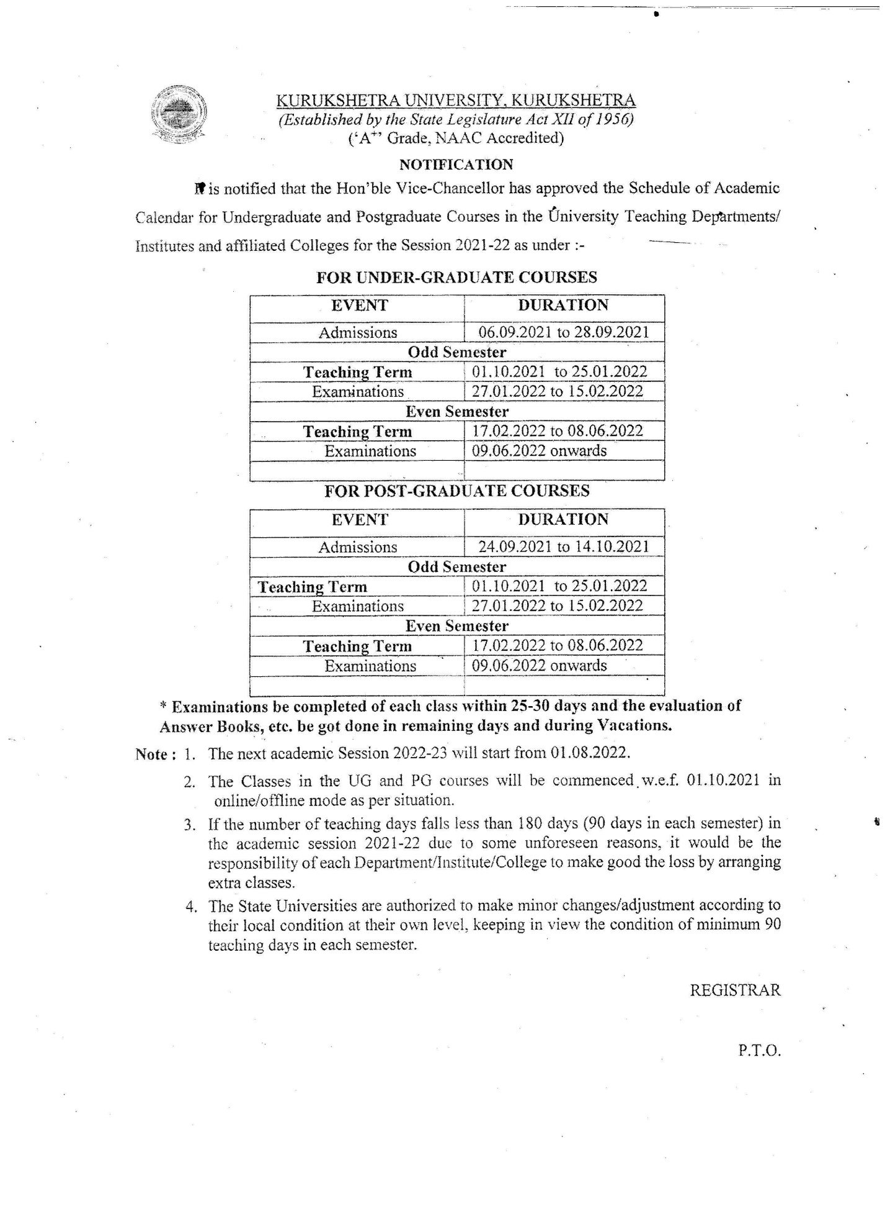

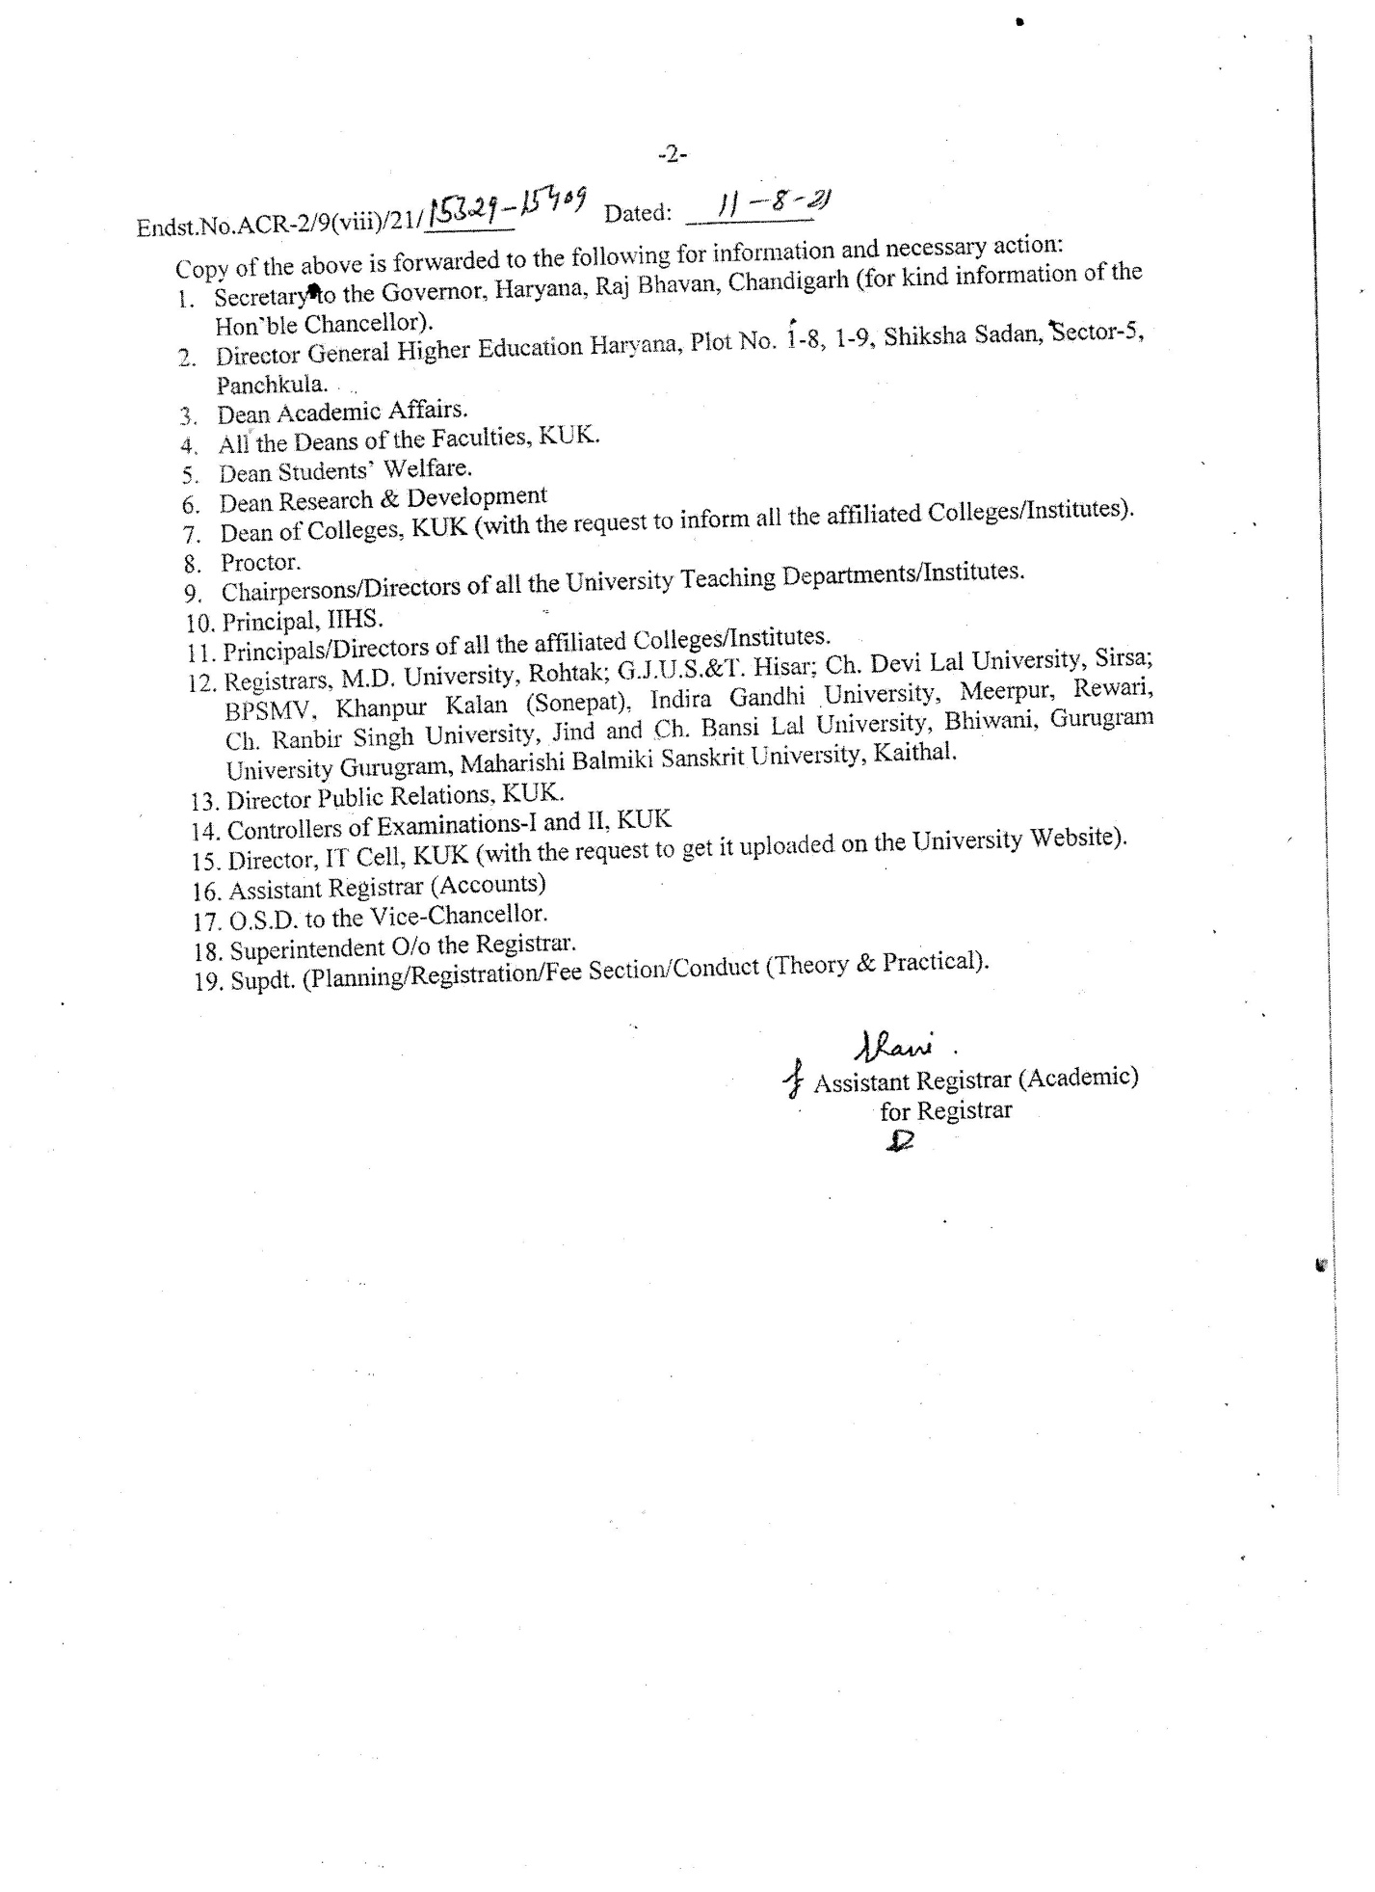

Note: (i) Extension/Change in dates for admission schedule of dates, if needed, will be allowed by the Vice-Chancellor.

(ii ) All the University Teaching Depts./Institutes and all the Maintained/Affiliated Colleges/Institutes will submit the admission list the next day from the last date of admission through E-mail arreg@kuk.ac.in.

E. |  | PREPARATION AND SUBMISSION OF REGISTRATION RETURN.
1. |  | The Principal/Chairman/Director of all the affiliated Colleges, University Teaching Departments are requested to send the Registration Return in CD form in addition to hardcopy (Registration Return on Proformae).  This CD must reach in the Registration Branch along with Regn. Return.  Principals/Chairpersons of the Colleges/Departments concerned are requested to send the Registration Returns, along with CD (in Microsoft Excel worksheet) complete in all respect and duly signed, along with required documents, affiliation letters (issued by the Colleges Branch, KUK) and prescribed fee preferably in one lot, failing which the Registration Returns will not be accepted.
2. |  | The Registration Returns alongwith instructions should be computerized in double space on both side on the prescribed forms and sent class-wise separately. Returns on single space/hand written or prepared otherwise will not be accepted in any case.
 |  | The Registration Returns of each class (Roll Number Wise) are to be prepared in Group-wise i.e. separate Returns for Science (Medical/Non-Medical/Commerce/Arts Students). The names of students of two different classes should not be entered on the same sheet. Separate sheets are to be used for each class. In case the Registration Returns are computerized, the format should be the same as prescribed by the University and sufficient space should be given after each line (Double Space)
 |  | The Registration Returns are to be signed at the specified place provided for the purpose by the Principal/Chairperson himself/herself and not by any other person on behalf of the Principals/Chairpersons.
 |  | Office copies of the Registration Returns may be kept by the College/Institute /Department concerned for record and future references.
3. |  | Registers of students are prepared strictly as per particulars given in the Registration Returns. Therefore, special care should be taken to ensure that the spellings of Name, Father’s name and Mother’s name of the students are typed exactly in accordance with the names given on the original certificates of qualifying examination. Later on, no correction in spellings (prefixes or suffixes) of the name will be made unless cogent reasons to the satisfaction of the Competent authority are given. It may be notified to the students that the mistakes in the Registration Cards, if any, be pointed out to the University through College concerned within 3 months from the date of issue of the Registration Cards.
 |  | If the particulars in the Registration Cards are found incorrect, the Registration Card together with the attested copy of the original certificate be sent to the Registration Branch for necessary correction. For any correction sought later for one reason or the other, candidates shall be required to pay Rs.500/-.
4. |  | The last date prescribed for the submission of Registration Returns and Migration Certificates (in original) is required to be followed strictly.
5. |  | In case any concession is granted to a particular student under the rules of the University for determining the eligibility for admission, the same must be included in the Registration Return with documentary proof thereof for record/reference and verification by the University Office.
6. |  | The prescribed Proformae (RF-10 & 10A) must be used invariably while sending the Registration Returns to the University.
7. |  | REGISTRATION RETURN (RF-1 & 21)
These are meant for only those students who have passed their qualifying examination from the Board of School Education, Haryana and are to be registered for the first time.

NOTE:- No Migration Certificate and its fee is to be obtained/charged from the students who have passed their qualifying examination from the Board of School Education, Haryana, and Haryana State Technical Board, Panchkula as they are not required to do so.

8. |  | REGISTRATION RETURN (RF-2 & 22)
i)  ii)  iii) |  | These are meant for only those students who have passed their qualifying examination from an Institution other than the Board of School Education, Haryana/Kurukshetra University Kurukshetra. The Registration Returns on the Format, referred to above must accompany:-  Migration certificates in original,  Attested photocopies of qualifying examination,  Eligibility Form (except of those students who have passed 10+2 exam. from CBSE & seeking admission in B.A./B.Sc./B.Com. Classes).
9. |  | REGISTRATION RETURN (RF-3)
 |  | These are meant for those students who have passed their qualifying examination from the Foreign Universities/Boards. For admission under this category of students the procedure of admission given under Admission of foreign students be kept in view.
10. |  | REGISTRATION RETURN(RF-4)
 |  | These are meant for those students who have been placed under Compartment in one subject only in the qualifying examination from the Board of School Education, Haryana, Bhiwani and have been admitted provisionally subject to qualifying their compartment subject. Since the admission is finalized on the basis of compartment cards, the photocopy of the same must be collected from all such students and the same must be attached with the Registration Return.
11. |  | REGISTRATION RETURN(RF-4 A)
i)  ii)  iii) |  | These are meant for those students who have been placed under compartment in one subject only in the qualifying examination from other than the Board of School Education, Haryana, Bhiwani and have been admitted provisionally subject to qualifying their compartment subject. The following documents may be sent alongwith Regn. Return (RF-4A):-  Since the admission is finalized on the basis of compartment cards, the photocopy of the same alongwith Migration Certificate must be collected from all such students and the same must be attached with Eligibility Form except Central Board of Secondary Education where eligibility form RF-12 is not necessary and Migration Certificate and send along with the Registration Return  Migration Certificate in original.  Attested photocopies of Compartment Card/DMC, since the eligibility is to be confirmed on the basis of having compartment in qualifying exam.  Eligibility Form (except of those students who have passed 10+2 exam. from CBSE & Board of School of Education Haryana, Bhiwani) seeking admission in B.A./B.Sc./B.Com. Class).
12. |  | REGISTRATION RETURN (RF-6)
 |  | These are to be used in the case of those students who are already registered with this University and have been promoted/admitted in the next higher class on the basis of passing of their lower examination and if they are otherwise eligible.
It will be the sole responsibility of the Principals/Chairpersons of the College/Department concerned to check the percentage of marks before admissions in case of such students who are already registered and whose particulars are to be sent on Registration Return Form (RF-6). The Principals/Chairpersons must fill in all the columns specified in Registration Return (RF-6).

No student should be given promotion to the higher class without having assigned the Registration Number. The Registration Number of the candidate must be checked carefully before mentioning the same on the Registration Return. Entire responsibility for any wrong/irregular promotion without finalization of eligibility of the lower class and appearance of such ineligible students in the Examination of next class will rest upon the Principals/Chairpersons of the Colleges/Departments concerned.

 | i) | The Registration Number of each student must be entered in the concerned column.
 | ii) | When the admission of a student is made after the last date of admission, the justification for late admission, if any, must be indicated.
13. | iii) | The result of each student must be indicated in the concerned column. In case of re-appear, number of re-appear papers must be indicated. However, pass provisional are not eligible for promotion/admission to next higher class.  Colleges/Institutes/Departments are requested to submit the Registration Returns along with RF-10 and RF-10-A Form (along with affiliation letters issued by the Colleges Branch of this University). Without RF-10 and RF-10-A Form Registration Return will not be accepted in any case
14. |  | In case of M.A./M.Sc. etc. where minimum %age is required, the same may be mentioned by taking into account the marks of all three years/all semesters. Similarly while considering the marks in the subject of M.A./M.Sc., the marks obtained in Post-Graduate subjects in all three years are to be counted.
15.  16. |  | In case any mistake comes to the notice of the Principal/Chairperson after the submission of Registration Returns to the University, intimation to this effect must be sent immediately to the Asstt./Dy. Registrar (Registration).  Principals/Directors of all affiliated Colleges/University Teaching Departments are to be requested to intimate this office after strucking off the name from the College roll or leaving the College, of any student for any reason within three days from the date of action to be initiated.  List of Professional courses run by the University Teaching Departments, Institutes, affiliated Colleges and through Distance Education as circulated by this office Letter No. Regn./R-III/11/708-908 dated 11-05-2011 is at “Annexure A”.
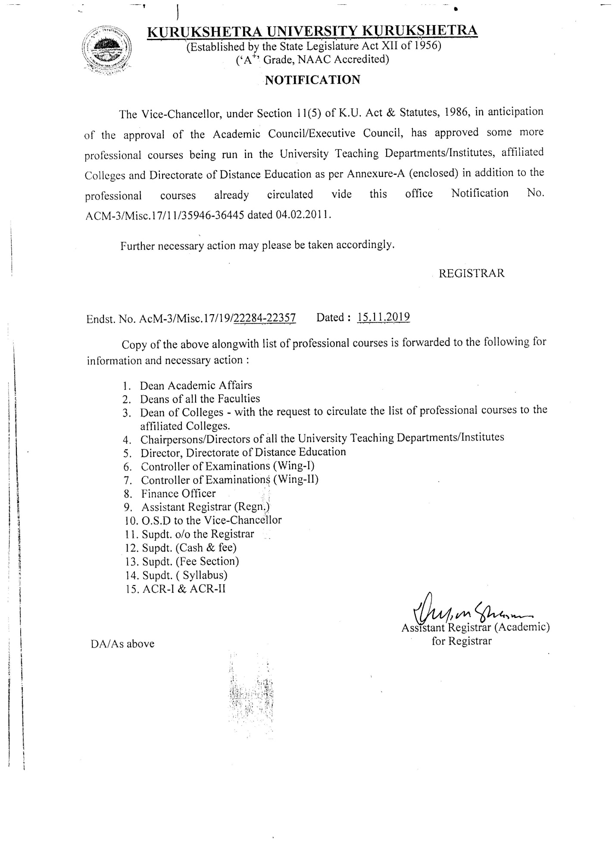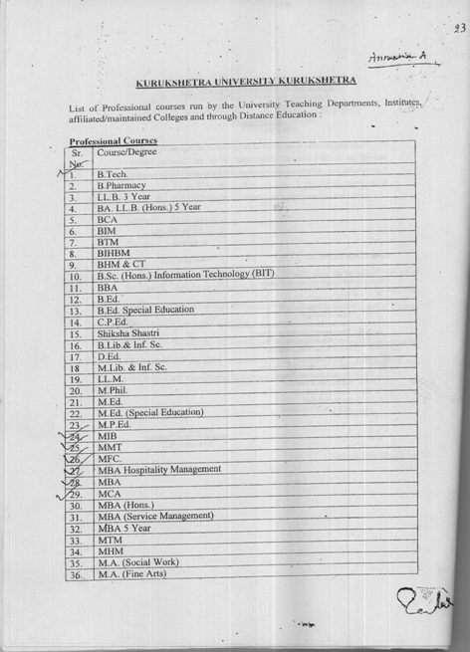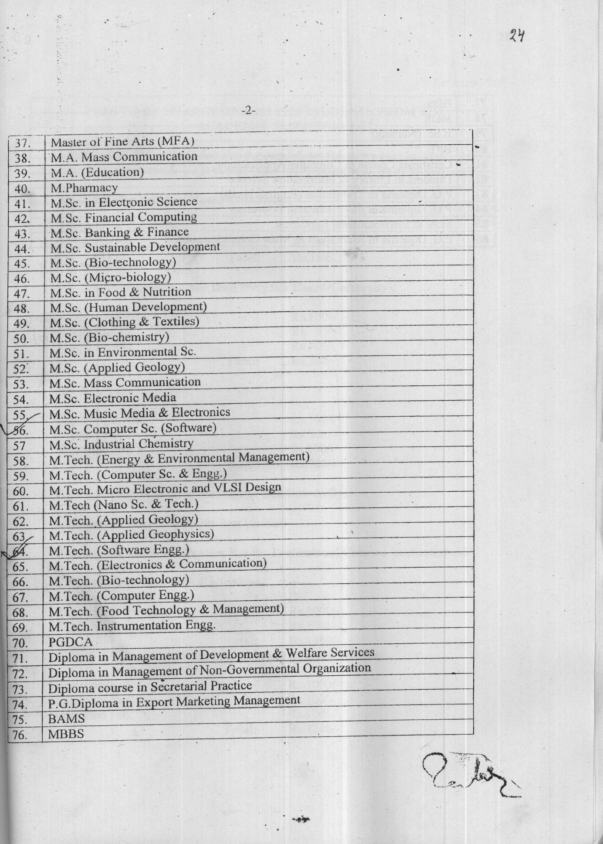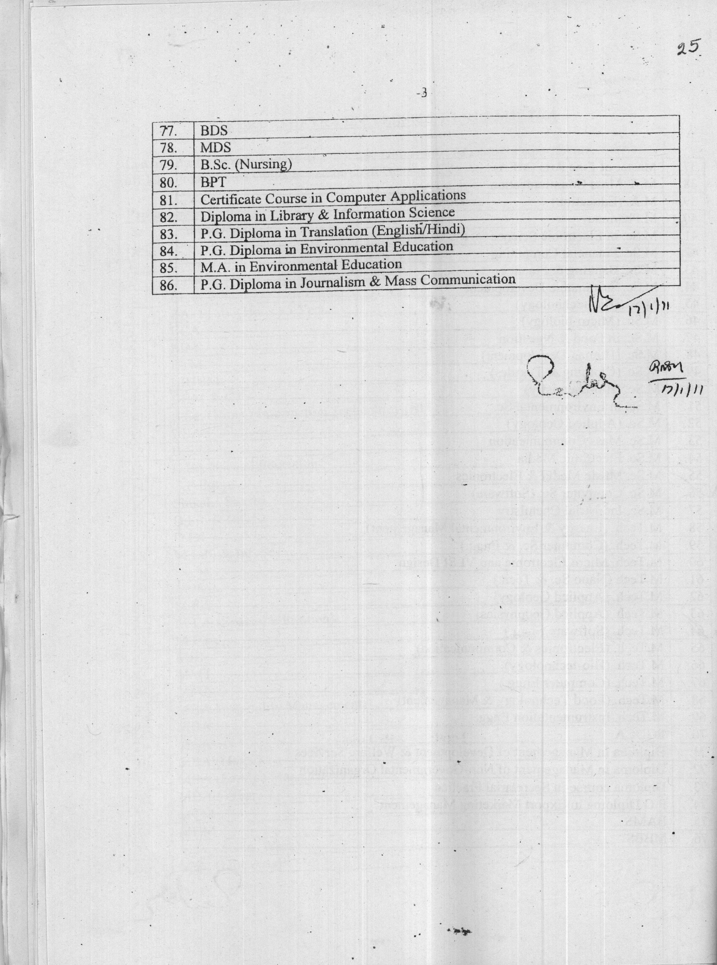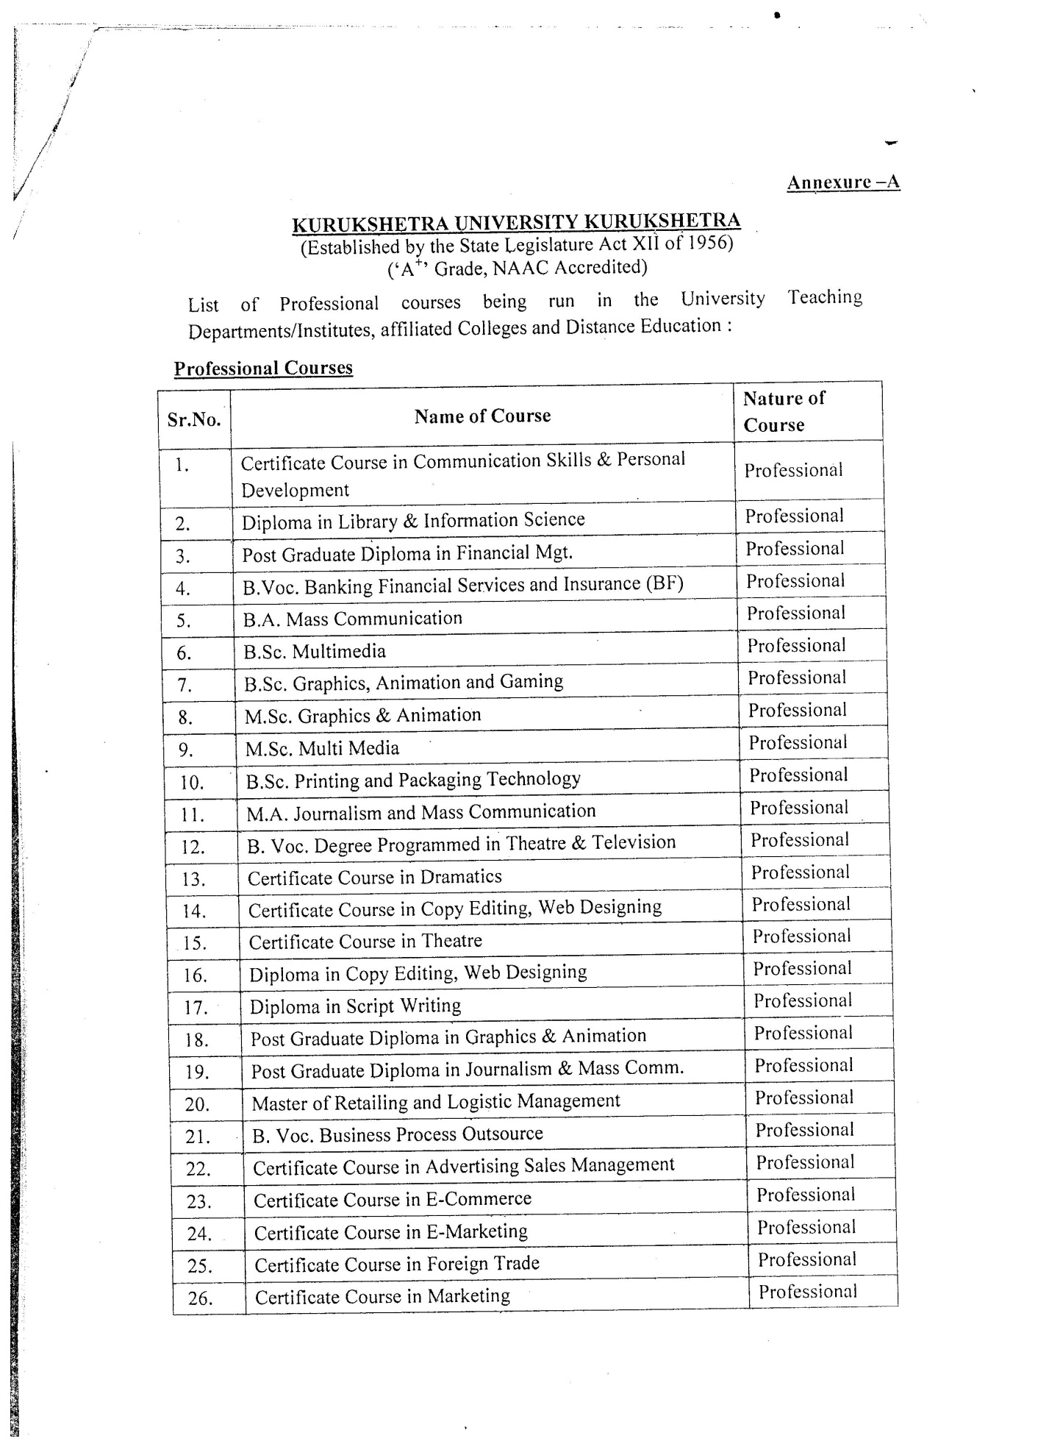
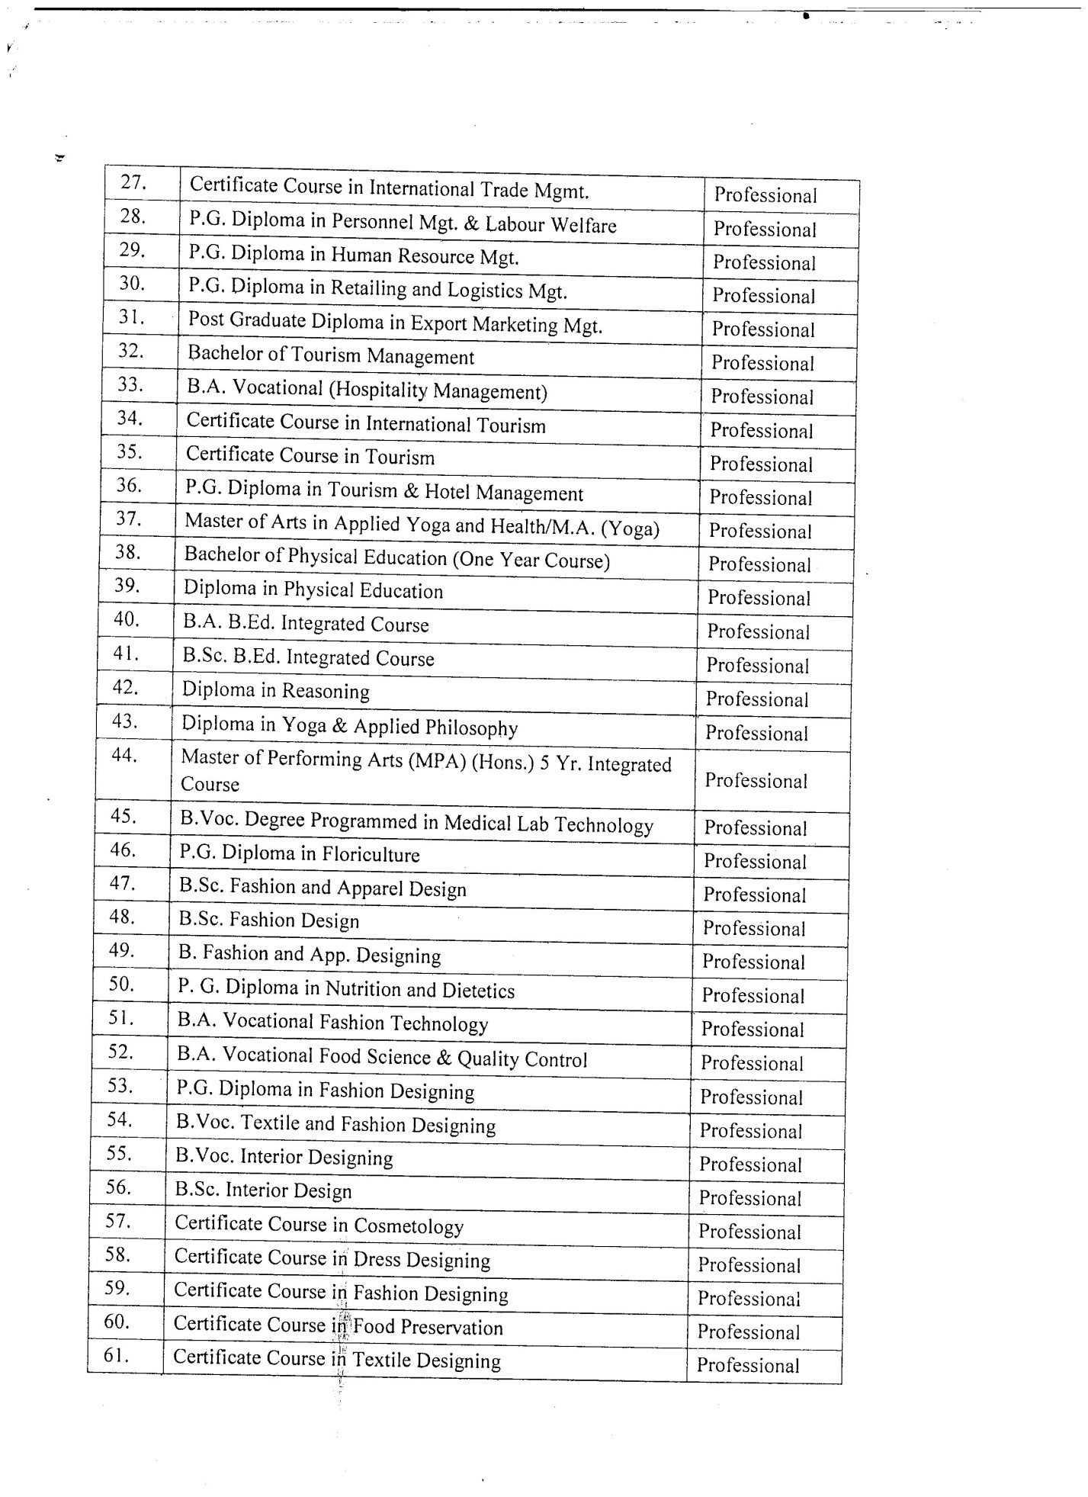
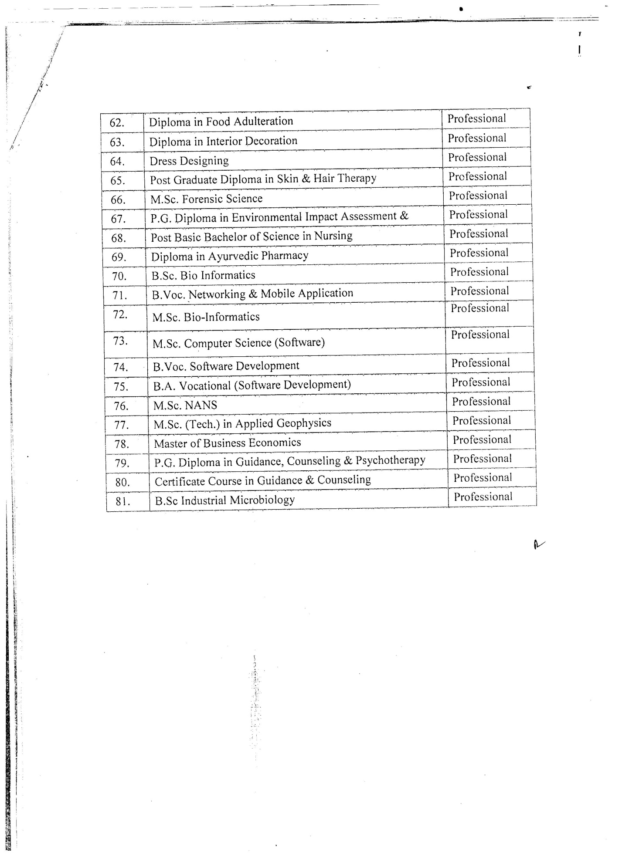
FEES TO BE CHARGED FROM THE STUDENTS FROM THE
ACADEMIC SESSION 2021-22

1. Registration & Continuation Fee for candidates for every case in Arts/ Science/Commerce & UTD except those listed below will be as under:-

RF-1 & 4 (for Haryana Board's Students)

Registration Fee Rs.500/-

RF-2 & 4A (Students other than Haryana Board/University).

Registration Fee Rs.500/-

RF-3(Foreign Students)

Registration Fee Rs.5000/-

RF-6 (Already registered students of this University):

Registration Continuation Fee Rs.200/- (per student)

II. Registration and Continuation Fee for Professional Courses (Annexure-A)

RF-21 (for Haryana Board's/Haryana State Technical Board’s Students)

Registration Fee Rs.1500/-

RF-2 & 4A (Students other than Haryana Board/University).

Registration Fee Rs.1500/-

RF-3 (Foreign Students)
Registration Fee Rs.5000/-

RF-6 (Already registered students of this University):

Registration Continuation Fee Rs.800/-

OTHER FEES:

Fee for Migration during the Course in
Arts/Science/Commerce etc. from other Universities Rs.3000/-
Correction in Name Rs.500/-
Re-issue of registration card/Correction slip Rs. 650/-

- Inter College Migration Fee (College to College):
B.Ed. | Rs. 15,000/-
M.Ed., B.Tech., M.Tech., LL.B., B.A.LL.B. (5-yr.) LL.M., MBA, MBA (5-yr.), MCA, B. Pharmacy, M. Pharmacy | Rs. 25,000/-
Other than above courses | Rs. 2000/-
- Inter University Migration Fee:
B.Tech., M.Tech., LL.B., B.A.LL.B. (5-yr.) LL.M., MBA, MBA (5-yr.), MCA, B. Pharmacy, M.Pharmacy | Rs. 30,000/-

(III) Schedule of submission of migration certificate:

Without late fee | 30st November
With late fee of Rs. 1,000/- | 1st Dec. to 31st of January of next year
With late fee of Rs. 2,000/- | 1st Feb. to 31st of March of next year
With late fee of Rs. 3,000/- | 1st April. to 30st of July of next year
With late fee of Rs. 5,000/- | 1st August to 31st October and thereafter admission will be treated as cancelled

Note:- If the admission schedule is extended after 30 November of the year then migration certificate will be accepted/submitted alongwith registration return only without late fees. After that migration certificate will be accepted/submitted with usual late fee as per above schedule.

(IV) If due to COVID-19 admission Schedule is extended then the following Schedule of submission of migration certificate will be applicable for the session 2021-22 only :

Without late fee | 31st January of next year
With late fee of Rs. 2,000/- | 1st Feb. to 31st March of next year
With late fee of Rs. 3,000/- | 1st April to 31st July of next year
With late fee of Rs. 5,000/- | 1st August to 31st October and thereafter admission will be treated as cancelled

(iii-a) “If any student who has got issued his/her Inter University Migration Certificate earlier from this University, shall be fully responsible for submission of the inter University Migration in the Dept./Institute/College at the time of admission, failing which the late migration fee to restore his/her old Regn. No. will be charged as per schedule given in the Instructions Guidelines for admission to various courses.

(iii-b) No student shall be allowed to appear in any examinations of Kurukshetra University Kurukshetra after issuance/receipt of inter University Migration Certificate.

The above rates of fee will be applicable to foreign students also.
 | University Establishment Charges (from fresh as well as continuation students from all affiliated/maintained colleges/Institute)
(i) | All Traditional UG Courses |  | Rs. 500.00 /-ANNUAL
(ii) | All Traditional PG Courses |  | Rs. 500.00 /-ANNUAL
(iii) | All Professional UG Courses |  | Rs. 600.00 /-ANNUAL
(iv) | All Professional PG Courses |  | Rs. 700.00 /-ANNUAL
(v) | All Engineering UG Courses |  | Rs. 800.00 /-ANNUAL
(vi) | All Engineering PG Courses |  | Rs. 900.00 /-ANNUAL
(vii) | All Hotel Management Courses |  | Rs. 800.00 /-ANNUAL
 | Development Fee (from fresh as well as continuation students from all affiliated/maintained colleges/Institute)
(i) | Art/Commerce/Science | Rs. 400.00 per student  (Rs. 300/- is to be remitted to the University)
(ii) | BBA | Rs. 1500.00 per student  (60% is to be remitted to the University)
(iii) | BCA/M.SC | Rs. 2000.00 per student  (60% is to be remitted to the University)
(iv) | M.P.ED/B.P.ED | Rs. 3000.00 per student  (60% is to be remitted to the University)
(v) | D.P.ED | Rs. 2000.00 per student  (60% is to be remitted to the University)
(vi) | Professional Courses approved by Apex regulatory bodies viz AICTE,NCTE,BCI,PCI,RCI, etc. other then UGC | Rs. 1600.00 per student  (60% is to be remitted to the University

The Registration fee, Development fee and Establishment Charges to be charged all fresh as well as continuation students from all the Colleges /Institutes affiliated/ maintained with by Kurukshetra University which to be remitted alongwith the Registration Returns.

Fee for Migration after the completion of Course for all Course (By Post) | Rs. 11,00/-(By post only no provision for issuing MC by hand)
Fee for Migration after the completion of Course for all Course (By Post) (Duplicate migration) | Rs. 3500/-(By post only no provision for issuing MC by hand)

- (a)Schedule of Examination Fee for various Under-graduate and Post-graduate courses w.e.f. December 2016/January 2017 examinations will be as under:-
Sr. No. | Examinations | Fee For Regular (fresh ) Students | Fee For regular ( re-appear) students | Fee for Ex-students | Fee for Private (Fresh/re-appear/compartmental ) students*
1. | Under-graduate traditional courses, Including Certificate and Diploma | Rs. 500/- | Rs. 650/- | Rs. 850/- | Rs. 1400/-
2. | Under-graduate Professional courses, including certificate and Diploma and B.Ed. (Except 2a & 2b below) | Rs. 600/- | Rs. 800/- | Rs. 1250/- | Rs. 1300/-
2(a) | Bachelor of International Hospitality & Business Management | Rs. 800/- | Rs. 1100/- | Rs. 1250/- | Rs. 1300/-
2(b) | Bachelor of Hotel Management | Rs. 1250/- | Rs. 1250/- | Rs. 1250/- | Rs.1300/-
3. | Post-graduate traditional courses | Rs. 600/- | Rs. 800/- | Rs. 1000/- | Rs. 1800/-
4. | Post-graduate Professional courses and Post-graduate Professional Diploma courses Including M. Ed. (Except 5) below | Rs. 700/- | Rs. 950/- | Rs. 1250/- | Rs. 1300/-
5 | Master of Hotel Management & Master of Tourism Management | Rs. 1250/- | Rs. 1250/- | Rs. 1250/- | Rs. 1300/-
6. | B.Tech. & M. Tech. Engg. | Rs. 1500/- | Rs. 1500/- | Rs.1500/- | ------------
7. | All Medical, Dental Ayurveda Physiotherapy, Nursing etc. | Rs. 1500/- | Rs. 1500/- | Rs. 1500/- | -------------
8. | Dissertation fee ( A) M. Tech. Engg.  (B) All other discipline classes/ courses | Rs. 3500/-  Rs. 1250/- | Rs. 3500/-  Rs. 1250/- | Rs. 3500/-  Rs. 1250/- | ------------

Note:(i) Fee for Private students at Column No. 6 includes Registration and Continuation fee. However, for regular Ex-students continuation fee amounting to Rs. 100/- will be charged extra only once during an academic Year.
- NSS FEE
Every College affiliated with this University will be charged N.S.S. fee of Rs. 20/- only per student. Out of this Rs.10/- per student shall be retained by the Colleges/Institute and Rs. 10/- shall be transferred to the Kurukshetra University, National Service Scheme through Deman Draft in favour of the Programme Coordinator ( NSS) on or before 31st December of every Academic session.
- The Alumni Fee of Rs. 200/- is to be charged by affiliated/maintained colleges/institutes from the fresh students at the time of admission. Every affiliated college/institutes to be deposited/transferred Rs. 50/- (University share) each student up to 31 December each year, in the account of Director ( Alumni) Kurukshetra University, Kurukshetra Alumni Association ( KUKAA) and all University Teaching Departments/Colleges/Institutes on the campus full amount (i.e. Rs. 1000/-) each student is to be deposited/transferred in the account of Director (Alumni) Kurukshetra University, Kurukshetra Alumni Association (KUKAA).
- Schedule of fee for sports are payable by the affiliated colleges in the shape of Bank Draft in favour of Secretary, Kurukshetra University Sports Council, payable at Kurukshetra University, Kurukshetra. The fee of the students be remitted soon after the admission process is over:
Sports Registration Fee per Annum
- Out of Rs. 220/- per head per annum collected on account of Sport Registration fee from each student at the time of admission, an amount of Rs. 135/- (Rupees one hundred thirty five only) per head per annum is to be sent in favour of Secretary, K.U. Sports Council. Rs. 80/- (Eighty per head per annum shall be retained by the Government/Non. Government affiliated colleges for their sports fund.
- In case of (UIET), the whole amount of Sports Registration Fee i.e. Rs. 220/- per student per annum shall be sent to the Secretary, K.U. Sports Council.
- The University Teaching Department /maintained colleges of Kurukshetra University shall pay an amount of Rs. 145/- (Rupees one hundred forty five only) per head per annum to the Secretary, K.U. Sports Council and an amount of Rs. 75/- (Seventy five only) per head per annum shall be retained by the college for sports fund.
- The Technical Education Colleges/Institute and affiliated to Kurukshetra University shall pay an amount of Rs. 375/- per head per annum to the Secretary, K.U.S. C. and an amount of Rs. 125/- per head per annum shall be retained by the College/Institutes for their sports fund .
Tournament Fee
Tournament Fee per annum at the following rates on the basis of total students admitted in the Colleges/Institutes are to be sent on the following rates:

- For colleges having total strength of
students up to 200. Rs. 600/-

- For colleges having total strength of
students from 201 to 500. Rs. 2,000/-
- For colleges having total strength of
Students from 501 to 1500. Rs. 4,000/-
- For colleges having total strength of
students from 1501 and above. Rs. 6,000/-
- In addition to the above, a strength certificate as under is also to be sent, along with the Sports Registration fee and Tournament Fee for audit purpose:
This is to certify that the payment of Sports Registration Fee of Rs. _______has been made @ Rs.________ per head per annum for _____ students admitted in my College/Institution during the session ________ The above said amount of Sports Registration Fee has been deposited accordingly and no balance is lying with this College/Institution on account of Sports Registration Fee.
Principal/Head of the Institution
- The Colleges in arrear of Sports Registration Fee and Tournament Fee shall not be allowed to participate in the Inter Collegiate Tournaments until they clear their outstanding dues.
- Both the Fees (i.e. Sports Registration Fee and Tournament Fee) are payable to K.U. Sports Council irrespective of whether a College/Institute participates in the Tournament/Sports meet or not.
- Youth Red Cross Fee Rs. 80/- p.a.to be charged and @ Rs. 40/- per student is to be deposited with the University by the affiliated Colleges/Institutes in the shape of Demand Draft in favour of Programme Co-ordinator, Youth Red Cross Unit (Colleges), Kurukshetra University, Kurukshetra. The fee shall be deposited up to 30th November of the same financial year.
- Holiday Home fee: Rs. 10/- per annum per student is to be deposited with the University by the affiliated colleges/institutes in the shape of Demand Draft in favour of Registrar KUK.
- The Youth Welfare Fee will be charged from the students of UTDs and affiliated/maintained colleges as per details given below:

(a) All Degree Colleges & Govt. Aided/maintained B.Ed. Colleges:-
Rs. 100/- per student per year will be charged from the students, out of which Rs. 50/- will be sent to the Director, Youth & Cultural Affairs Deptt., KUK and Rs. 50/- will be retained by the college for their cultural activities. The Bank Draft may be prepared in favour of “ SECRETARY K. U. CULTURE COUNCIL FUND, KURUKSHETRA” payable at kurukshetra.

(b) All B. Ed. & Professional Colleges excluding Govt. Aided/maintained (B.Ed. Colleges):-
Rs. 500/- per student per year will be charged from the students, out of which Rs. 375/- will be sent to the Director, Youth & Cultural Affairs Deptt., KUK and Rs. 125/- will be retained by the College for their cultural activities. The Bank Draft may be prepared in favour of “ SECRETARY K. U. CULTURE COUNCIL FUND, KURUKSHETRA” payable at Kurukshetra.

- University Instt. of Engg. & Tech., Kurukshetra (UIET):-
Rs. 200/- per student per year will be charged from the students, out of which Rs. 150/- will be sent to the Director, Youth & Cultural Affairs Deptt., KUK and Rs. 50/- will be retained by the College for their cultural activities. The Bank Draft may be prepared in favour of “SECRETARY K. U. CULTURE COUNCIL FUND, KURUKSHETRA” payable at kurukshetra.

IMPORTANT NOTE: All fees (Registration Fee, Development Fee, and Establishment Charges) related to Registration Branch will be deposited alongwith the Registration Return.

STATE-WISE LIST OF FAKE UNIVERSITIES DECLARED BY THE UNIVERSITY GRANTS COMMISSION AS ON September,2016
Bihar
- Maithili University/Vishwavidyalaya, Darbhanga, Bihar

Delhi
- Commercial University Ltd., Daryaganj, Delhi
- United Nations University, Delhi
- Vocational University, Delhi
- ADR-Centric juridical University, ADR House, 8J, Gopala Tower, 25 Rajendra Place, New Delhi
- Indian Institute of Science and Engineering, New Delhi
- Viswakarma open University for self –Employment, Rozgar Sewasadan, 672, Sanjay Enclave, opp GTK Depot. Delhi-110033.

Karnataka
- Badganvi Sarkar World Open University Education Society, Gokak, Belgaum, Karnataka

Kerala
- St. John’s University, Kishnattam, Kerala

Maharashtra
- Raja Arabic University, Nagpur, Magarashtra

West Bengal
11. Indian Institute of Alternative Medicine, Kolkatta.
12. Institute of Alternative Medicine and Research, 8-A, Diamond Harbour Road, Buitech inn, 2nd Floor Thakurpurkur, Kolkatta-700063

Uttar Pradesh
13. Varanaseya Sanskrit Viswavidyalaya, Varanasi (UP) jagatpuri, Delhi.
14. Mahila Gram Vidyapith/Vishwavidyalaya, (Women’s University) Prayag, Allahabad
15. Gandhi Hindi Vidyapith, Prayag, Allahabad (U.P.)
16. National University of Electro Complex Homeopathy, Kanpur (Uttar Pradesh)
17. Netaji Subhash Chandra Bose University (Open Univ.), Achaltal, Aligarh, U.P.
18. Uttar Pradesh Vishwavidyalaya, Kosi Kalan, Mathura (Uttar Pradesh)
19. Maharana Partap Shiksha Niketan Vishwavidyalaya, Pratapgarh (Uttar Pradesh)
20. Indraprastha Shiksha Parishad, Institutional Area, Khoda, Makanpur, Nodia Phase-II, (U.P).
21. Gurukul Vishwavidyalaya, Vrindavan, Uttar Pradesh

Odisha
22. Nababharat Shiksha Parishad, Anupoorna Bhawan, Plot No. 242, Pani Tanki Road, Shaktinagar, Rourkela 769014
23. North Orissa University of Agriculture & Technology, Odissa

Examinations of the following Boards not recognized for the purpose of higher studies:
- All India Board of Secondary Education, New Delhi
- Uttar Madhyama & Purva Madhyama of Mdu Rohtak (Gurukul Jhajjar Scheme)
- Central Board of Higher Education, New Delhi
- Board of Adult Education and Training/Board Shiksha Sansthan, New Delhi
- Any Diploma/Exams. of Prachin Kala Kendra, Chandigarh
- Bhartiya Siksha Prishad, Lucknow
- Board of Higher Secondary Education, Delhi
- Hindi Sahitya Sammelan, Prayug, Allahabad(U.P)
- Indian Education Council of U.P., Luchnow
Note: This is not an exhaustive list of fake Universities and Board, Before finalizing the admissions the updated list of recognized examinations of the UGC and the Board of School Education, Haryana, Bhiwani is also required to be consulted.

RF-I/21 KURUKSHETRA UNIVERSITY KURUKSHETRA
REGISTRATION RETURN FOR STUDENTS WHO HAVE PASSED THE SENIOR SECONDARY CERTIFICATE EXAMINATION FROM THE BOARD OF SCHOOL EDUCATION, HARYANA AND ARE TO BE REGISTERED FOR THE FIRST TIME
Important Note: Before filling up this form, Important Instructions for this session and instructions given overleaf must be read carefully.

Name of College/Department…………………………………………… Last Date of Admission with/without late fee …………….….. Class/Course……………………Year………..…
Academic Session: ……………………… Date of Submission of Registration Return………………………….. Group(Arts, Medical, Non-Medical, Commerce etc.)……………….
Total No. of sanctioned seats …………………………………. Total candidates admitted: (i) Through Counseling …………..… (ii) By Management ……………
Sr. No. | Date of receipt of Migration | Regn. No. assigned/ to be assigned by the University | Date of Counseling | Date of Admi-ssion | College Roll No | NAME OF STUDENT  (In Block letters) | FATHER’S NAME  (In Block letters) | MOTHER’S NAME  (In Block letters) |  |  | Particulars of passing of 10+2/  Lower qualifying Examination |  |  |  |  |  |  |  |  | For office use only
 |  |  |  |  |  |  |  |  | Date of Birth(As per Matric Cert.) | Name of Univ/ Board | Name of Exam | Year and Session | Roll No. | Subject of Comptt. in case RF4/4A | Marks Obtained/  Total Marks | Whether belongs to Gen/BC/ SC/ST | Marks in PCB/PCM | Category Open/Mgt. | Merit Rank No.
 |  |  |  |  |  | (Spellings should be typed as per certificate of qualifying examination)
1 | 2 | 3 | 4 | 5 | 6 | 7 | 8 | 9 | 10 | 11 | 12 | 13 | 14 | 15 | 16 | 17 | 18 | 19 | 20 | 21
1
2
3
4
5
6
7
8
9
10

 | INSTRUCTIONS |  |  | CERTIFICATE
1. | The Registration Return duly typed, College/Dept. Roll No. wise on double space having font size 12 in capital letters and Upper & bottom margin should not be less than 1.5 inches . The Registration Returns must be prepared/printed on legal size paper. |  | i) | Certified that
 |  |  |  | Every student has been admitted according to relevant Ordinance of the examination inforce at the time of admission as printed in the Kurukshetra University Calendars and they fulfill all the eligibility conditions
2. | The Registration Return of each Class should be prepared roll no. wise & class-wise, i.e. separately for Medical, Non-Medical, Arts, Commerce etc. |  | ii) | Eligibility form RF-12 alongwith attested photocopies has been sent to the University for checking their eligibility
3. | Office copies of each sheet on plain paper must be retained for record and future references. |  | iii) | The equivalence of lower examination passed by each student has been checked and found in order.
4. | Only the relevant prescribed proformae of the Registration Returns meant for various categories of students (on the basis of their lower exams. of various Boards/Universities) may be used. |  | iv) | The number of students, admitted to this course, is within the quota of seats sanctioned by the University.
5. | The spellings of name, father’s and mother’s, name of each student may be typed in capital letters and checked exactly in accordance with those recorded in the original certificates of lower examinations before submitting the Registration Return. |  | v) | This college has been granted affiliation by the Kurukshetra University for the course vide letter No. ______________ dated ______________(letter enclosed)
6. | Each sheet of the Registration Return should invariably be signed by the Principal/Chairperson at the specified place and not by any other or on behalf of the Principal. |  | vi) | It has been checked that the student admitted have not been disqualified by any University/Board in India. An undertaking to their effect has also been taken from each student.
7. | Photocopies duly attested only by the Head of the Inst./Dept. of the lower examination passed and the Migration Certificate in original of each student must be submitted in one lot with the Eligibility application form for confirmation of their admissions not later than 10 days after the last date of admission with late fee of Rs.50/- and so on. |  | vii) | The spellings of student’s name, father’s and mother’s name, date of birth, marks obtained and Regn.No.(if any) noted in this Return, are in accordance with the particulars mentioned in the original certificate of the lower examination passed from the University/Board concerned.
 |  |  | viii) | A sum of Rupees………………… on account of Registration and Eligibility Fee has been remitted to the Registrar, Kurukshetra University, Kurukshetra vide Bank Draft No……………… drawn on Bank……………………… or deposited vide University Fee Receipt No…………………Dated…………
Signature of the Principal
Date:………. (Office Stamp)

RF-2/22 KURUKSHETRA UNIVERSITY KURUKSHETRA
REGISTRATION RETURN FOR STUDENTS WHO HAVE MIGRATED FROM OTHER UNIVERSITIES/BOARDS OTHER THAN THE BOARD OF SCHOOL EDUCATION, HARYANA, BHIWANI AND ARE TO BE REGISTERED FOR THE FIRST TIME
Important Note: Before filling up this form, Important Instructions for this session and instructions given overleaf must be read carefully.
Name of College/Department…………………………………………… Last Date of Admission with/without late fee …………….….. Class/Course………………Year……
Academic Session: ……………………… Date of Submission of Registration Return………………………….. Group(Arts, Medical, Non-Medical, Commerce etc.)……………….
Total No. of sanctioned seats …………………………………. Total candidates admitted: (i) Through Counseling …………..… (ii) By Management ……………
Sr. No. | Date of receipt of Migration | Regn. No. assigned/ to be assigned by the University | Date of Counseling | Date of Admi-ssion | College Roll No | NAME OF STUDENT  (In Block letters) | FATHER’S NAME  (In Block letters) | MOTHER’S NAME  (In Block letters) |  |  | Particulars of passing of 10+2/  Lower qualifying Examination |  |  |  |  |  |  |  |  | For office use only
 |  |  |  |  |  |  |  |  | Date of Birth(As per Matric Cert.) | Name of Univ/ Board | Name of Exam | Year and Session | Roll No. | Subject of Comptt. in case RF4/4A | Marks Obtained/  Total Marks | Whether belongs to Gen/BC/ SC/ST | Marks in PCB/PCM | Category Open/Mgt. | Merit Rank No.
 |  |  |  |  |  | (Spellings should be typed as per certificate of qualifying examination)
1 | 2 | 3 | 4 | 5 | 6 | 7 | 8 | 9 | 10 | 11 | 12 | 13 | 14 | 15 | 16 | 17 | 18 | 19 | 20 | 21
1
2
3
4
5
6
7
8
9
10

 | INSTRUCTIONS |  |  | CERTIFICATE
1. | The Registration Return duly typed, College/Dept. Roll No. wise on double space having font size 12 in capital letters and Upper & bottom margin should not be less than 1.5 inches . The Registration Returns must be prepared/printed on legal size paper. |  | i) | Certified that
 |  |  |  | Every student has been admitted according to relevant Ordinance of the examination inforce at the time of admission as printed in the Kurukshetra University Calendars and they fulfill all the eligibility conditions.
2. | The Registration Return of each Class should be prepared roll no. wise & class-wise, i.e. separately for Medical, Non-Medical, Arts, Commerce etc. |  | ii) | Eligibility form RF-12 alongwith attested photocopies has been sent to the University for checking their eligibility.
3. | Office copies of each sheet on plain paper must be retained for record and future references. |  | iii) | The equivalence of lower examination passed by each student has been checked and found in order.
4. | Only the relevant prescribed proformae of the Registration Returns meant for various categories of students (on the basis of their lower exams. of various Boards/Universities) may be used. |  | iv) | The number of students, admitted to this course, is within the quota of seats sanctioned by the University.
5. | The spellings of name, father’s and mother’s, name of each student may be typed in capital letters and checked exactly in accordance with those recorded in the original certificates of lower examinations before submitting the Registration Return. |  | v) | This college has been granted affiliation by the Kurukshetra University for the course vide letter No. ______________ dated ______________ (letter enclosed)
6. | Each sheet of the Registration Return should invariably be signed by the Principal/Chairperson at the specified place and not by any other or on behalf of the Principal. |  | vi) | It has been checked that the student admitted have not been is disqualified by any University/Board in India. An undertaking to their effect has also been taken from each student/
7. | Photocopies duly attested only by the Head of the Inst./Dept. of the lower examination passed and the Migration Certificate in original of each student must be submitted in one lot with the Eligibility application form for confirmation of their admissions not later than 10 days after the last date of admission with late fee of Rs.50/- and so on. |  | vii) | The spellings of student’s name, father’s and mother’s name, date of birth, marks obtained and Regn.No.(if any) noted in this Return, are in accordance with the particulars mentioned in the original certificate of the lower examination passed from the University/Board concerned
 |  |  | viii) | A sum of Rupees………………… on account of Registration and Eligibility Fee has been remitted to the Registrar, Kurukshetra University, Kurukshetra vide Bank Draft No……………… drawn on Bank……………………… or deposited vide University Fee Receipt No…………………Dated…………
Signature of the Principal
Date:……….
(Office Stamp)

RF-4 KURUKSHETRA UNIVERSITY KURUKSHETRA
REGISTRATION RETURN FOR STUDENTS WHO ARE PLACED UNDER COMPARTMENT IN ONE SUBJECT ONLY IN THE SENIOR SECONDARY CERTIFICATE EXAMINATION FROM THE BOARD OF SCHOOL EDUCATION, HARYANA, BHIWANI AND ARE TO BE REGISTERED FOR THE FIRST TIME
Important Note: Before filling up this form, Important Instructions for this session and instructions given overleaf must be read carefully.
Name of College …………………………………….……………………… Last Date of Admission with/without late fee……………. Course/Class……………
Academic Session: ……………………… Date of Submission of Registration Return………………………….. Group(Arts, Medical, Non-Medical, Commerce etc.)…………
Sr. No. |  | Date of receipt of Migration | Regn. No. assigned/ to be assigned by the University | Date of Counseling | Date of Admi-ssion | College Roll No | NAME OF STUDENT  (In Block letters) | FATHER’S NAME  (In Block letters) | MOTHER’S NAME  (In Block letters) |  |  |  |  |  | Particulars of passing of 10+2/  Lower qualifying Examination |  |  |  |  |  |  |  |  | For office use only
 |  |  |  |  |  |  |  |  |  |  | Date of Birth(As per Matric Cert.) | Name of Univ/ Board |  |  | Name of Exam | Year and Session | Roll No. | Subject of Comptt. in case RF4/4A | Marks Obtained/  Total Marks | Whether belongs to Gen/BC/ SC/ST | Marks in PCB/PCM | Category Open/Mgt. | Merit Rank No.
 |  |  |  |  |  |  | (Spellings should be typed as per certificate of qualifying examination)
1 |  | 2 | 3 | 4 | 5 | 6 | 7 | 8 | 9 |  | 10 | 11 |  |  | 12 | 13 | 14 | 15 | 16 | 17 | 18 | 19 | 20 | 21
1
2
3
4
5
6
7
8
9
10
1. | INSTRUCTIONS  The Registration Return duly typed, College/Dept. Roll No. wise on double space having font size 12 in capital letters and Upper & bottom margin should not be less than 1.5 inches . The Registration Returns must be prepared/printed on legal size paper. |  |  |  |  |  |  |  |  |  |  |  | i) | CERTIFICATE  Certified that
 |  |  |  |  |  |  |  |  |  |  |  |  |  | the spelling of the names, father's and mother's names and date of birth noted in the Return are in accordance with the particulars entered in the Result gazette/original certificate;
2. | The Registration Return of each Class should be prepared roll no. wise & class-wise, i.e. separately for Medical, Non-Medical, Arts, Commerce etc. |  |  |  |  |  |  |  |  |  |  |  | ii) | the student fulfill the conditions of percentage of marks laid down under the Ordinance in force for admission to the course concerned and the combination of the subjects offered by each student is in consequence with the syllabus and Ordinances.
3. | Office copies of each sheet on plain paper must be retained for record and future references. |  |  |  |  |  |  |  |  |  |  |  | iii) | this college has been granted affiliation by the University for this course; (letter enclosed)
4. | Only the relevant prescribed proforma of the Registration Returns meant for various categories of students (on the basis of their lower exams. of various Boards/Universities) may be used. |  |  |  |  |  |  |  |  |  |  |  | iv) | the students admitted have not been disqualified by any University/Board as per undertaking given by each student to this effect.
5. | The spellings of name, father’s and mother’s, name of each student may be typed in capital letters and checked exactly in accordance with those recorded in the original certificates of lower examinations before submitting the Registration Return. |  |  |  |  |  |  |  |  |  |  |  | v) | The students admitted have compartment in one subject only in the lower exam i.e. 10+2, and
6.  7. | Photocopy of 10+2 (Compt. Card) in one subject only duly attested by the Principal of the college concerned must be sent with the Regn. Return.  Each sheet of the Registration Return should invariably be signed by the principal/ Chairperson at the specified place and not by any other or on behalf of the Principal. |  |  |  |  |  |  |  |  |  |  |  | vi) | A sum of Rupees……………………….. on account of Registration and Eligibility Fee has been remitted to the Registrar, Kurukshetra University, Kurukshetra vide Bank Draft No. …………………….. drawn on Bank ………………………… or deposited vide University Fee Receipt No…………………….. dated…………….
8.  9. | In Compartment cases percentage of marks for admission shall be determined by taking into account the marks obtained in the subject passed by the candidates plus the minimum pass marks in the compartment subject as per example given below:-  Suppose a student seeking admission to B.Com-I, who has been placed under Compartment in the subject of Accountancy in the 10+2 Examination and has obtained the marks in each Subject as under:- Hindi Core 45/100, English 50/100, Accountancy 10/100 (Compartment) Commerce 52/100, Economics 40/100.  His eligibility will be determined as under:-  Hindi Core45+English50+Accountancy33(minimum pass marks)+ Commerce52 + Economics40=220/500=44%. If by calculating the percentage of marks of the candidate comes to less than 40% Commerce Group he will not be eligible for admission.  Separate Regn. Return may be filled up for paid/Non-paid seats in each course. |  |  |  |  |  |  |  |  |  |  |  | vii) | Certified that actual sanctioned strength approved by the University vide letter No……………………..dated ……………… for the said course/class is………………… students and actual admission made by the college is …………………….. students.  Signature of the Principal  (Office stamp)
RF-4A KURUKSHETRA UNIVERSITY KURUKSHETRA
REGISTRATION RETURN FOR STUDENTS WHO HAVE MIGRATED FROM OTHER UNIVERSITY/BOARDS OTHER THAN BOARD OF SCHOOL EDUCATION, HARYANA, BHIWANI AND PLACED COMPARTMENT IN ONE SUBJECT ONLY BE REGISTERED FOR THE FIRST TIME
Important Note: Before filling up this form, Important Instructions for this session and instructions given overleaf must be read carefully.
Name of College …………………………………….……………………… Last Date of Admission with/without late fee……………… Course/Class…………………...
Academic Session: ……………………… Date of Submission of Registration Return………………………….. Group(Arts, Medical, Non-Medical, Commerce etc.)…………
Sr. No. | Date of receipt of Migration | Regn. No. assigned/ to be assigned by the University | Date of Counseling | Date of Admi-ssion | College Roll No | NAME OF STUDENT  (In Block letters) | FATHER’S NAME  (In Block letters) | MOTHER’S NAME  (In Block letters) |  |  | Particulars of passing of 10+2/  Lower qualifying Examination |  |  |  |  |  |  |  |  | For office use only
 |  |  |  |  |  |  |  |  | Date of Birth(As per Matric Cert.) | Name of Univ/ Board | Name of Exam | Year and Session | Roll No. | Subject of Comptt. in case RF4/4A | Marks Obtained/  Total Marks | Whether belongs to Gen/BC/ SC/ST | Marks in PCB/PCM | Category Open/Mgt. | Merit Rank No.
 |  |  |  |  |  | (Spellings should be typed as per certificate of qualifying examination)
1 | 2 | 3 | 4 | 5 | 6 | 7 | 8 | 9 | 10 | 11 | 12 | 13 | 14 | 15 | 16 | 17 | 18 | 19 | 20 | 21
1
2
3
4
5
6
7
8
9
10

1. | INSTRUCTIONS  The Registration Return duly typed, College/Dept. Roll No. wise on double space having font size 12 in capital letters and Upper & bottom margin should not be less than 1.5 inches . The Registration Returns must be prepared/printed on legal size paper. |  | i) | CERTIFICATE  Certified that
 |  |  |  | every student has been admitted according to relevant Ordinances of the examination in force at the time of admission as printed in the Kurukshetra University Calendars and they fulfill all the eligibility conditions;
2. | The Registration Return of each Class should be prepared roll no. wise & class-wise, i.e. separately for Medical, Non-Medical, Arts, Commerce etc. |  | ii) | Eligibility form RF-12 alongwith original M.C. has been sent to the University;
3. | Office copies of each sheet on plain paper must be retained for record and future references. |  | iii) | The equivalence of lower examination passed by each student has been checked and found in order;
4. | Only the relevant prescribed proformae of the Registration Returns meant for various categories of students (on the basis of their lower exams. of various Boards/Universities) may be used. |  | iv) | This college has been granted affiliation by the Kurukshetra University for the course; (letter enclosed)
5. | The spellings of name, father’s and mother’s, name of each student may be typed in capital letters and checked exactly in accordance with those recorded in the original certificates of lower examinations before submitting the Registration Return. |  | v) | it has been checked that the students admitted have not been disqualified by any University/Board in India. An undertaking to this effect has also been taken from each student;
6.  7. | Each sheet of the Registration Return should invariably be signed by the Principal/Chairperson at the specified place and not by any other or on behalf of the Principal.  Original Migration Certificate alongwith Eligibility application form must be sent to the University alongwith Regn. Return. |  | vi) | the spellings of student's name, father's and mother's name, dated of birth, Marks obtained and Regn. No.(if any) noted in this Return, are in accordance with the particulars mentioned in the original certificate of the lower examination passed from the University/Board concerned;
8.  9. | In Compartment cases percentage of marks for admission shall be determined by taking into account the marks obtained in the subject passed by the candidates plus the minimum pass marks in the compartment subject as per example given below:-  Suppose a student seeking admission to B.Com-I, who has been placed under Compartment in the subject of Accountancy in the 10+2 Examination and has obtained the marks in each Subject as under:- Hindi Core 45/100, English 50/100, Accountancy 10/100 (Compartment) Commerce 52/100, Economics 40/100.  His eligibility will be determined as under:-  Hindi Core 45+English50+Accountancy33(minimum pass marks)+Commerce52+Economics40=220/500=44%.  If by calculating the percentage of marks of the candidate comes to less than 40% Commerce Group he will not be eligible for admission.  Separate Regn. Return may be filled up for NRI paid seats in each course. |  | vii)  viii) | A sum of Rupees……………………….. on account of Registration and Eligibility Fee has been remitted to the Registrar, Kurukshetra University, Kurukshetra vide Bank Draft No. …………………….. drawn on Bank ………………………… or deposited vide University Fee Receipt No…………………….. dated…………….  Certified that actual sanctioned strength approved by the University vide letter No……………………..dated ……………… for the said course/class is………………… students and actual admission made by the college is …………………….. students.  ………………………………  Signature of the Principal  …………..  (Office stamp)

RF-6 (FOR TDC/PROFESSIONAL COURSES)

KURUKSHETRA UNIVERSITY KURUKSHETRA

CONTINUATION FEE RETURN
Academic Session: ………………………
Name of College/Department…………………………………………… Last Date of Admission without late fee …………….……….. Class/Course…………………Year………..…
Date of Submission of Registration Return………………………….. Group(Arts, Medical, Non-Medical, Commerce etc.)…………………….
Total No. of sanctioned seats …………………………………. Total candidates admitted: (i) Through Counseling …………..… (ii) By Management …………….
Important Note: Before filling up this form, Important Instructions for this session and instructions given overleaf must be read carefully.
Sr. No. | Date of receipt of Migration | Regn. No. assigned/ to be assigned by the University | Date of Counseling | Date of Admi-ssion | College Roll No | NAME OF STUDENT  (In Block letters) | FATHER’S NAME  (In Block letters) | MOTHER’S NAME  (In Block letters) |  |  | Particulars of passing of 10+2/  Lower qualifying Examination |  |  |  |  |  |  |  |  | For office use only
 |  |  |  |  |  |  |  |  | Date of Birth(As per Matric Cert.) | Name of Univ/ Board | Name of Exam | Year and Session | Roll No. | Subject of Comptt. in case RF4/4A | Marks Obtained/  Total Marks | Whether belongs to Gen/BC/ SC/ST | Marks in PCB/PCM | Category Open/Mgt. | Merit Rank No.
 |  |  |  |  |  | (Spellings should be typed as per certificate of qualifying examination)
1 | 2 | 3 | 4 | 5 | 6 | 7 | 8 | 9 | 10 | 11 | 12 | 13 | 14 | 15 | 16 | 17 | 18 | 19 | 20 | 21
1
2
3
4
5
6
7
8
9
10

 | INSTRUCTIONS |  |  | CERTIFICATE
1. | The Registration Return duly typed, College/Dept. Roll No. wise on double space having font size 12 in capital letters and Upper & bottom margin should not be less than 1.5 inches . The Registration Returns must be prepared/printed on legal size paper. |  | i) | Certified that
 |  |  |  | the students admitted have secured the required percentage of marks in the lower examination as required under the Ordinances prescribed for admission to……………………….
2. | The Registration Return of each Class should be prepared roll no. wise & class-wise, i.e. separately for Medical, Non-Medical, Arts, Commerce etc. |  | ii) | the names and Regn. Nos. noted in this Return are in accordance with the names and Regn. Nos. entered in Result Gazette or supplied by the University;
3. | Office copies of each sheet on plain paper must be retained for record and future references. |  | iii) | Number of students admitted in this class does not exceed the number of sanctioned seats;
4. | Only the relevant prescribed proformae of the Registration Returns meant for various categories of students (on the basis of their lower exams. of various Boards/Universities) may be used. |  | iv)  v) | The names of all the students admitted in the above class have been included in the Regn. Return;  These students have not migrated from this University to another University/Board.
5. | The spellings of name, father’s and mother’s, name of each student may be typed in capital letters and checked exactly in accordance with those recorded in the original certificates of lower examinations before submitting the Registration Return. |  | vi)  vii) | The College/Dept. is exclusively responsible for wrong admissions of students, if any, indicated in the Regn. Return.  The College has been granted affiliation by the University for this course vide letter No. ……………………………. dated………………….
6.  7.  8. | Each sheet of the Registration Return should invariably be signed by the Principal/Chairperson at the specified place and not by any other or on behalf of the Principal.  Details of Marks Obtained out of Total Marks in Col. No. 16 be shown only for admission to all such courses when the condition of minimum percentage of marks is required under the relevant Ordinance.  The student who are already registered and still stand migrated from this University to another University/Board, be not shown in this Return. Instead, these students may be shown in RF-2 Return. |  | viii) | The students admitted have not been disqualified by this or any other University/Board; and a sum of Rupees………….on account of Continuation fee of the students has been remitted to the Registrar, Kurukshetra University, vide Bank Draft No………………………….. dated…………………... University Receipt No………………………………dated………….…………
9. | No student may be promoted in next-higher class until/unless he/she has been registered.
………………………………
Signature of the Principal

(Office stamp)
R.F-10
FORWORDING LETTER FOR SUBMISSION OF REGISTRATION RETURNS

This letter is to be filled class wise along with the registration return must reach the university office within prescribed time from the last date of admission with/without late fee.

Ref. No……………………… Registered Parcel Dated:-…………………...

From To

The Principal/Chairman, The Asstt./Dy. Registrar (Registration),
……………………….. Kurukshetra University,
………………………. Kurukshetra -136119
Dear Sir,
I am sending here with Registration Return of this college/Department, duly filled in and arranged according to the guidelines/instruction supplied by the University.
Number of student admitted to various classes in accordance with the schedule of dates for admissions circulated by the University for the current session (In no case the name of the students have been include in the Registration Returns, whose late admissions have not so far been got approved by the University, as required under the rules). The students who member of the Scheduled caste/ Scheduled Tribe/Backward classes have been noted in the list mentioned overleaf. Performa of 10A duly filled in is allotted herewith.
It is certified that the admissions have been made as per provisions given in the Prospectus/University Calendar/Ordinances of the concerned Course/class.
It is also certified that the distribution of seats as well as Reservation Policy as applicable and notified by the Government and University from time to time has been implemented by the College/Department into and any deviation in this regard is the responsibility of the Principal/Director of the College/Institute.

Category of Regn. Return No. of Boys No. of Girls Total No. of students Amount remitted

R.F-1 …………… …………... ……………….. ………………..
R.F-2 …………… …………... ……………….. ………………..
R.F-3 …………… …………... ………………... ………………..
R.F-4 …………… …………... …………..…… ………………..
R.F-4A …………… …………... ……………..… ………………..
R.F-6 …………… …………... ……………..… ………………..
R.F-13 …………… …………... …………..…… ………………..
R.F-21 …………… …………... …………..…… ………………..
R.F-22 …………… …………... …………..…… ………………..
Enclosures:-

(i) Total pages of Registration Return …………….. Yours Faithfully

(ii) Total Original Mig. Certificate………………….. …..…...……………………….
(iii) D.D for Rs……………………………………… Signature of Principal/Chairman
(iv) Proforma 10A (alongwith affiliation letters) (Office Stamp)………………...
___________________________________________________________________________________________________________
To be filled by the Registration Branch

- File no. of College/Deptt……………………………………………………………………...
- Date of receipt in the University Office …………vide R.P No. ………..…….Dated…...............

…………………… …………………………… ……………………….
Receipt Clerk Assistant Asstt./Dy. Registrar (Regn.)
___________________________________________________________________________________________________________

To be filled in by the fee Receipt Section

Received Rs……………………… vide University Receipt No. …………...Dated…...............

…………………………… ……………………………………
Fee Receipt Clerk Asstt. (fee Receipt)
P.T.O.

List of the Students who belong to Scheduled Caste/Scheduled Tribe/Backward Classes:

Sr.  No. | Regn. No. | College/Deptt. Roll No. | Class | Name of the Student | Remarks

………………………………………
Signature of the Principal/Chairman
(Office Stamp)………………………
………………………………………
Dated……………………

RF– 10 A KURUKSHETRA UNIVERSITY, KURUKSHETRA
STATEMENT SHOWING THE SUBJECT WISE SANCTIONED SEATS AND STUDENTS ADMITTED
FOR THE SESSION _____________________________

SR. No. | Subject | B.A/B.Sc./Part – I |  | B.A/B.Sc./Part – II |  | B.A/B.Sc./Part – III |  | K.U. letter No. & date vide which sanction allowed
 | General Course | Sanctioned seats | Students admitted | Sanctioned seats | Students admitted | Sanctioned seats | Students admitted
1. | English
2. | Hindi
3. | Punjabi
4. | Sanskrit
5. | History
6. | Economics
7. | Pol. Sci.
8. | Sociology
9. | Pub. Admn.
10 | Philosophy
11 | History of art
12 | Education
13 | Social work
14 | Military science
15 | Music
16 | Art
17 | Psychology
18 | Home Science
19 | Geography
20 | Mathematics
21 | Physics
22 | Chemistry
23 | Botany
24 | Zoology
25 | Commerce
26 | Statistics
27 | Comp. Application
28 | Electronic Science
29
30
31
32
33
Restructured course
1. | Indl. & Actl. Science
2. | Electronics
3. | Comp. Sci.
4. | Genetics
5. | FPANH
6. | Rural Industrialization
7. | Local Self Govt.
8. | Office Management
9. | Marketing
10 | Labour Welfare
11 | Commercial Art
12 | Health & Phy. Edu.
13 | Arch. Musm. & Tour
14
Certified that : -
- The above statement includes only those subjects in which the University has already allowed affiliation.
- The above statement has been checked and found correct.
- No. of students admitted does not exceed the number of sanctioned seats.
Dated : __________________ Signature of the Principal _____________
College stamp_________________

RF-10A
Kurukshetra University Kurukshetra
Statement Showing the Sanctioned Seats vis-à-vis students admitted in various courses/classes
name of college/institute……………………………….. academic session………………….
Sr.  No. | Name of Course/Class (Medical/Non-Medical/Restructures/Vocational etc. | No. of  Sanctioned Seats | K.U. Letter No. & Date vide which sanction of seats allowed (letter enclosed issued by the Colleges Branch) | No. of  Students admitted  as shown in Regn. Return | No. of Excess admissions,  if any | Remarks/Reasons in case excess admissions
1
2
3
4
5
6
7
8
9
10

Certified that :-
1. The above statement has been checked and found correct.
2. The University has already accorded affiliation to run these courses/classes.
3. Number of students admitted does not exceed the number of sanctioned seats.
4. The admissions have been made in accordance with the University Rules & Ordinances.
Signature of Principal…………………………..
Dated………………. College Stamp…………………..……………….

R.F.-11
Eligibility Certificate Case No. …………………..
KURUKSHETRA UNIVERSITY KURUKSHETRA

APPLICATION FORM FOR OBTAINING ELEGIBILITY CERTIFICATE FOR SEEKING ADMISSION TO THE POST-GRADUATE COURSES OF THE UNIVERSITY TEACHING DEPARTMENTS AND AFFILIATED COLLEGES FOR THE SESSION ………………………

A student who wishes to join the University Teaching Department/affiliated colleges on the basis of the qualification obtained from another University or Board, shall obtain Eligibility certificate by completing this form which must be alongwith the Original Detailed Marks Certificate of the lower examination on the basis of which admission is sought. Admission to the University Teaching Department/Post Graduate affiliated colleges without production of Eligibility certificate shall be invalid. As regards other details of admission procedure. Chairperson/Principal of the concerned Dept./College should be contacted.

- Name of Candidate (Mr./Miss/Mrs.)……………………………………………………… (in block letters)
- Father’s Name : Shri………………………………………………..………………………………………
- Mother’s Name Mrs………………………………………………..………………………………………
- Date of Birth…………………………………………(attach photo attested copy of Matric Certificate).
- Registration No. of Kurukshetra University (if any)…………………………..…………………………..
- Name of University Department you wish to join…………………………...…………………………….
- Course to which admission is being sought………………………….Semester/Year…………..…………
- (a) Fill in the below given columns on the basis of which the eligibility to this course is claimed (Also attach original Certificates)

Name of the  Examination Passed | Year | Month | Roll No. | Subject/ Papers | Marks Obtained | Minimum Pass Marks | Aggregate %age of Marks | University | Result/Pass/ Fail/Re-appear

(b) Original Certificate attached:
(i) ……………………..……….…………....(ii)…………….……..………..………….(iii)………………………………...………

- Permanent home Address……………………………………………………………………………………..………........………
……………………………………………………………………………………………………………………………...………
- University Receipt/Postal Order No Rs. 80/- and so on …………………………….…... Dated ……..…………………………
- Do you belong to Scheduled Caste/Scheduled Tribe ….................................................... (if so, also attach original certificate).
- Are you appearing at any other examination from this or other University simultaneously ………………………………..…….
If yes, Give full particulars.
Name of Examination …………………….…… Roll No……………………Session……….……. University………..………..
- Have you ever been disqualified from any examination by any Board/University…………..…….. (Yes/No) If yes, decision thereof…………………..…Examination……………………University……………….………..Year & Session………………
DECLARATION TO BE GIVEN BY THE CANDIDATE
I do hereby declare that the statement given above is true to the best of my knowledge and belief and nothing has been concealed.
If any information is found incorrect, I own the responsibility and the University, may take any action against me. I further declare:
- that I have not passed the same or equivalent examination from this or any other University/Education Board for which I am seeking admission.
- that no action of any kind against me is pending or has been decided in any University/Education Board which makes me ineligible for admission to the course.

Encl.: (As above) Dated……………… ……………………….
Signature of Applicant

Important Note:- Migration certificate is to be submitted by the applicant to the Chairperson/Principal of the Department/Colleges concerned within one month from the date of admission.
Certified that the name of the said candidate is to the Selection list at Sr. No…………………..
Certified that the eligibility of the candidate has been checked and he/she is eligible to take admission in the Department for the above course under the latest University Rules/Ordinance and as per list of examinations recognized by this University. The admission has been allowed provisionally to the candidate at his/her own risk and responsibility subject to confirmation of the eligibility by the University.

DA:
(i)………………………. Signature of the
(ii)……………………… Chairperson
(With Office Seal)
P.T.O.

FOR OFFICE USE

- Name of the Course…………….………………………………………………..Group………………..........................................
……………….………Examination passed from ……………………………….…………………….University is recognized as equivalent to …………………….………... as at Sr. No…………………Page No……..……… of the list of Examination of the Kurukshetra University.

- Percentage of marks and other condition Prescribed in the Ordinance………………………………………………………….....

- Eligibility for admission to…………………………………………………..………………..Class/Course.
The applicant has obtained……………….………..marks out of………………………..and has obtained the percentage of marks for admission to the Course.
- His admission is provisional subject to submission of …………………………………………………………………………….

- Fee has been entered in the Fee Register at Sr. No …………………….……...........Eligibility ……………….……. Certificate No………………………

Eligibility checked on the basis of original documents and provision of the Allowed Ordinance.

Dealing Official Assistant Superintendent (Regn.) Asstt./Dy. Registrar (Regn.)

R.F.-12
KURUKSHETRA UNIVERSITY KURUKSHETRA

APPLICATION FORM FOR OBTAINING ELEGIBILITY OF STUDENT SHOWN IN RF-2 RETURN

Important Note :-(i) The Application Form duly filled in by the student and completed in all respect, must be sent to the University within 10 days from the date of admission;
(ii) A student joining a college affiliated to this University, on the basis of having passed qualifying exam., from
another recognized University/Board (except Board of School Education, Haryana), are required to apply for eligibility by completing this form;
(iii) The application Form alongwith Photostat copy of detailed Marks Certificate duly attested by the Principal of the college concerned alongwith original Migration certificate must be sent.
-------------------------------------------------------------------------------------------------------------------------------------------------------------------
- Name of Candidate (Mr./Miss/Mrs.)……………………………………………… (in block letters as per lower exam)
- Father’s Name: Shri………………………………………………..……………………………………...……..………
- Mother’s Name Mrs………………………………………………..…………………………………………….………
- Date of Birth…………………………………………(as recorded in Matric Certificate)
- Registration No. of Kurukshetra University (if any)…………………………..…………………….…………………..
- Class/Course to which admission is sought…………………………...………………Section…………………..…….
Class Roll No………………………..Subject offered (i)……………………..(ii)……………………………….……
(iii)…………………………… (iv)…………………………….(v)…………………………(vi)………….…………..
- Fill in the below given columns on the basis of which the admission is sought.
Name of the  Examination Passed | Year | Month | Roll No. | Subject/ Papers | Marks Obtained in each subject | Max.  Marks in subject | Total marks obtained | Aggregate %age of Marks | Result Pass/Fail/  Re-appear | University/Board
 |  |  |  | 1…………….  2…………….  3…………….  4…………….  5……………. | …………..  …………..  …………..  …………..  ………….. | ……...……  …….……..  …….……..  …….……..  …………...

8. Are you appearing in any compartmental/deficient subject in the supplementary examination from this or any other
University/ Board?
If so, name of University/Board…………………………………….. Name of Exam…………………………………..
Comptt./deficient subject……………………………………………
9. Correspondence Address…………………………………………………………………………………………………
……………………………………………………………………………………………………………………………
10. Permanent Home Address……………………………………………………………………………………………….
……………………………………………………………………………………………………………………………
11. Do you belong to Scheduled Caste/Scheduled Tribe…………………………………………………………………….

I do hereby declare as under:-
- That the statement given above is true to the best of my knowledge and belief and nothing has been concealed.
- That I have not passed the same or equivalent examination from this or any other University/Education Board of which I am seeking admission.
- That no action of any kind against me is pending or has been decided in any University/Education Board which makes me ineligible for admission to the course.
- That I am taking admission in the college at my own risk and responsibility subject to confirmation of my eligibility by the University. If I am declared ineligible at any stage no admission to the course and my admission is cancelled by the University abinitio, I shall have no claim whatsoever for this.

Date……………………….. …………………………… ……………………………
(Signature of the Father/Guardian (Signature of Student)

Certified that the eligibility of the candidate has been checked and he/she is eligible to take admission in the college for the above course under the latest University rules/Ordinance and as per list of examination recognized by this University. The admission has been allowed provisionally to the candidate at his/her own risk and responsibility subject to confirmation of the eligibility by the University. The original certificate/DMC has been checked and a Photostat copy duly attested by the undersigned alongwith original migration certificate is attached herewith for the purpose. If the candidate is declared ineligible for admission to the above course for non-fulfillment of any of the eligibility conditions and the provisional admission of candidate is cancelled, the college shall have no claim whatsoever for this.

DA: Original certificate attached
(i)………………………. Signature of the Principal
(ii)………………………
(With Office Seal)
Dated ………………. P.T.O.

FOR OFFICE USE

1. Name of the Course applied for ……………………………………………..Subject Offered …….................................
(If applicable)
2. Name of the Lower Examination passed……………….………………………….……………………. University/Board…………………………………………………………………………… Recognized as equivalent to …………………….………... at Sr. No…………………Page No……..……… of the Equivalency list.
3. Percentage of marks and other condition Prescribed in the Ordinance…………………………………………………..
Other conditions prescribed in the Ordinance……………………………………………………………………………

4. Percentage of marks obtained by the student…………………………………………………………………………….
Other conditions which the candidate fulfils……………..………………………………………………………………
5. (i) Whether the student belong to SC/ST (Mention Category)…………………………………………………….
(ii) Percentage of concession allowed………………………………………………………………………………
6. Dated of Receipt of Original Migration Certificate………………………………………………………………………
Fee for late submission of Migration Certificate of Rs…………………………………………………………………...
Entered in the Registrar (if applicable at Sr. No………………………………………………………………………….

7. Eligible subject to submission of…………………………………………………………………………………………

Clerk Assistant Superintendent (Regn.) Asstt./Dy. Registrar(Regn.)

REASON IF NOT ELIGIBLE

------------------------------------------------------------------------------------------------------------------
------------------------------------------------------------------------------------------------------------------
------------------------------------------------------------------------------------------------------------------
------------------------------------------------------------------------------------------------------------------
------------------------------------------------------------------------------------------------------------------
------------------------------------------------------------------------------------------------------------------
------------------------------------------------------------------------------------------------------------------
------------------------------------------------------------------------------------------------------------------
------------------------------------------------------------------------------------------------------------------
------------------------------------------------------------------------------------------------------------------
------------------------------------------------------------------------------------------------------------------
------------------------------------------------------------------------------------------------------------------

Clerk Assistant Superintendent (Regn.) Asstt./Dy. Registrar(Regn.)

R.F.-12B
Eligibility Certificate Case No. …………………..
KURUKSHETRA UNIVERSITY KURUKSHETRA

APPLICATION FORM FOR OBTAINING ELEGIBILITY CERTIFICATE IN RESPECT OF FOREIGN STUDENTS
FOR THE SESSION ………………………

A student who wishes to join the University Teaching Department/affiliated colleges/Directorate of Correspondence Courses on the basis of the qualifications obtained from another Foreign University or Board shall obtain Eligibility certificate by completing this form which must be accompanied alongwith the Original Detailed Marks Certificates of the lower examination on the basis of which admission is sought. Admission to the University Teaching Department/affiliated colleges/ Directorate of Correspondence Courses without production of Eligibility certificate shall be invalid. As regards other details of admission procedure concerned Chairperson/Principal/Director of Correspondence Courses is to be contacted.

- Name of Candidate (Mr./Miss/Mrs.)……………………………………………… (in block letters as per lower exam)
- Father’s Name: Shri………………………………………………..……………………………………...……..………
- Mother’s Name Mrs………………………………………………..…………………………………………….………
- Date of Birth…………………………………………(attach attested photocopy of Matric Certificate)
- Registration No. of Kurukshetra University (if any)…………………………..…………………….…………………..
- Name of University Department you wish to join………………………………………………….……………..…….
- Course to which admission is being sought………………………………………..Semester/Year…………………….
- (a) Fill in the below given columns on the basis of which the eligibility to this course is claimed
Also attach original Certificates)
Name of the  Examination Passed | Year | Month | Roll No. | Subject/ Papers | Marks Obtained | Minimum Pass Marks | Aggregate %age of Marks | University | Result/Pass/ Fail/Re-appear

(b) Original Certificate attached:
(i) ……………………..……….………….... (ii)…………….……..………..…………. (iii)………………………………...…
(c) Other Documents Attached:
(i) Student Visa…………………….……. (ii) Passport………………………… (iii) Medical Aid Certificate………...…………….
(iv) Residential Permit……………………………

9. Permanent home Address…………………………………………………………………...……………………………
…………………………………………………………………………………………………………………………….
10. University Receipt/Postal Order No Rs. 500/- ……………………………….…... Dated ……..…………...…………
11. Do you belong to Scheduled Caste/Scheduled Tribe …....................................... (if so, also attach original certificate).
12. Are you appearing at any other examination from this or any other University simultaneously ………………………………..……. If yes, Give full particulars.
Name of Examination …………………….…… Roll No……………Session……….…. University………..………
13. Have you ever been disqualified from any examination by any Board/University…………..…….. (Yes/No)
If yes, decision thereof…………………..…Examination……………………University……………….………..Year & Session……………
DECLARATION TO BE GIVEN BY THE CANDIDATE
I do hereby declare that the statement given above is true to the best of my knowledge and belief and nothing has been concealed.
If any information is found incorrect, I own the responsibility and the University may take any action against me. I further declare:
- that I have not passed the same or equivalent examination from this or any other University/Education Board for which I am seeking admission.
- that no action of any kind against me is pending or has been decided in any University/Education Board which makes me ineligible for admission to the course.

Encl.: (As above) Dated……………… ……………………….
Signature of Applicant

Note:- Migration certificate is to be submitted by the applicant to the Chairperson of the Department/Principal of the Colleges concerned within one month from the date of admission.

P.T.O.

FOR OFFICE USE

1. Name of the Course…………………………………………………..Group………………..........................................
……………….………Examination passed from ……………………………….…………………….University is recognized as equivalent to …………………….………... as at Sr. No…………………Page No……..……… of the list of Examination of the Kurukshetra University.

2. Percentage of marks and other condition Prescribed in the Ordinance…………………………………………………..

3. Eligibility for admission to…………………………………………………..………………..Class/Course.
The applicant has obtained……………….………..marks out of………………………..and has obtained the percentage of marks for admission to the Course.

4. His admission is provisional subject to submission of ……………………………………………………………….….

5. Fee has been entered in the Fee Register at Sr. No …………………….……...........Eligibility ……………….……. Certificate No………………………

Eligibility checked on the basis of original documents and Allowed provision of the Ordinance.

Dealing Official Assistant Superintendent (Regn.) Asstt./Dy. Registrar (Regn.)

KURUKSHETRA UNIVERSITY, KURUKSHETRA
(Established by State Legislature Act XII of 1956)
(“A” Grade, NAAC Accredited)
NO DUES CERTIFICATE
(To be issued by the Authorized Officer with Office Stamp)
Name of the Institute/College: …………………………………………………………………………………………………………………………
Name of the Course: ………………………………………………………….. Session: …………………………………………
Total Roll Nos: ……………………………………………………………………. Date of Examination: ……………………
Colleges Branch  No Dues are Pending.  Signature of the Branch Officer  (Stamp) | Registration Branch  No Dues are Pending.  Signature of the Branch Officer  (Stamp) | Youth & Cultural Affairs  No Dues are Pending.  Signature of the Branch Officer  (Stamp)
Sports Department  No Dues are Pending.  Signature of the Branch Officer  (Stamp) | Youth Red Cross Unit  No Dues are Pending.  Signature of the Branch Officer  (Stamp) | Alumni Association  No Dues are Pending.  Signature of the Branch Officer  (Stamp)
Holiday Home  No Dues are Pending.  Signature of the Branch Officer  (Stamp) | NSS  No Dues are Pending.  Signature of the Branch Officer  (Stamp) | Examination Branch  No Dues are Pending.  Signature of the Branch Officer  (Stamp)

As per above reports, the referred Institute/College has cleared the dues so, admit, cards/roll numbers may be issued and this certificate be retained by the set Incharge for future reference.

(Signature of the Branch Officer)
Result Branch ………………………….
Dated ……………………………………..
Supdt…………….Result Branch …………

RF -13 KURUKSHETRA UNIVERSITY KURUKSHETRA

Return for supplying particulars and remittance of late admission fee of the students provisionally admitted late in various courses after the last date with late fee of Rs. 100/-.
Note: - (i) In addition to late fee of Rs. 100/- (to retained by the College/Deptt.) as additional late fee @ Rs. 100/- per day per student may be realized.
(ii) The consolidated list completed in all respects, alongwith late fee, must reach the University latest by the last date fixed as per schedule already notified or within 10 days of the date of late admission.
(iii) No admission be allowed after the last date fixed for admission with late fee of Rs. 100/- per day per student and fixed by the University from time to time, unless otherwise allowed by the University.

Sr.  No. | Name of the Student | Class/Course | Roll No. | Last date of admission with late fee of Rs. 100/- | Date of Admission | Delay involved  (No. of Days) | Amount of Late Fee @ Rs. 100/- per day per student

Certified that the late fee chargeable under the Rules Verification of Receipt of Fee by the Fee Section in respect of University
has been realized from all the students admitted late. Teaching Department only.

Encl.: Bank Draft No……………… ………………………….. Receipt of Rs………………………..verified
Dated……………………………… Signature of the Principal/Chairperson Dated…………… ……………………………..
For Rs…………………………….. …………………………... (Incharge Fee Section, K.U.K.)

SPEED-POST
O.I.G.S.

To

_______________________________________

_______________________________________

_______________________________________

_______________________________________

From:-
Sr. Admn officer. /Dy. Registrar (Registration)
Kurukshetra University, Kurukshetra

