

|  |  |  |
| --- | --- | --- |
| **Certificate Course Name** | **Eligibility**  **(Minimum Condition)** | **Intake** |
| Electrochemistry from Basics to Applications | B.Sc. Degree Holder in Physical Sciences or B. Tech Degree Holder in Engineering | 80 (Maximum) |

**Kurukshetra University RUSA Project Society invites applications for following ONLINE Short Term Certificate Course under RUSA 2.0.**

Application Deadline: 20th June, 2021  
Selection Criteria: First Come, First Serve Basis  
Number of Seats: 80  
Course Duration: 54 Hrs. (approx.)   
Registration Fee: Rs. 300/-

**KURUKSHETRA UNIVERSITY RUSA PROJECT SOCIETY**



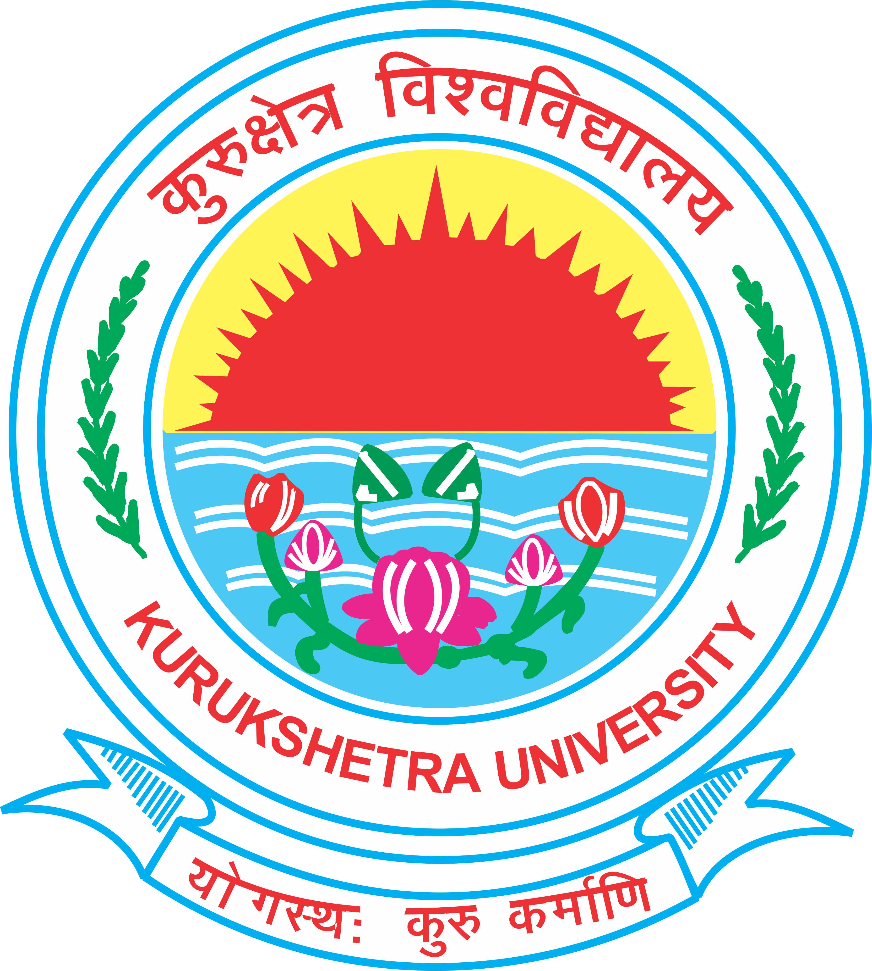

For more details visit: <https://sites.google.com/view/electrochemkuk2021/home>